Student Mental Health and Wellbeing Strategy
  - 2021 Annual Report

Table of Contents
Kaurna Acknowledgment 2
Student Mental Health and Wellbeing Strategy 3
1. Background 3
2. Strategy launch 3
3. Promotion 4
4. Governance 6
5. Action Area Highlights 6
6. Summary 9

Kaurna Acknowledgment

We acknowledge and pay our respects to the Kaurna people, the traditional custodians whose ancestral lands on which the University of Adelaide was built. We also acknowledge and support Aboriginal and Torres Strait Islander people’s cultural practices and cultural sensitivities. We acknowledge the deep feelings of attachment and relationship of the Kaurna people to country and we respect and value their past, present and ongoing connection to the land and cultural beliefs.

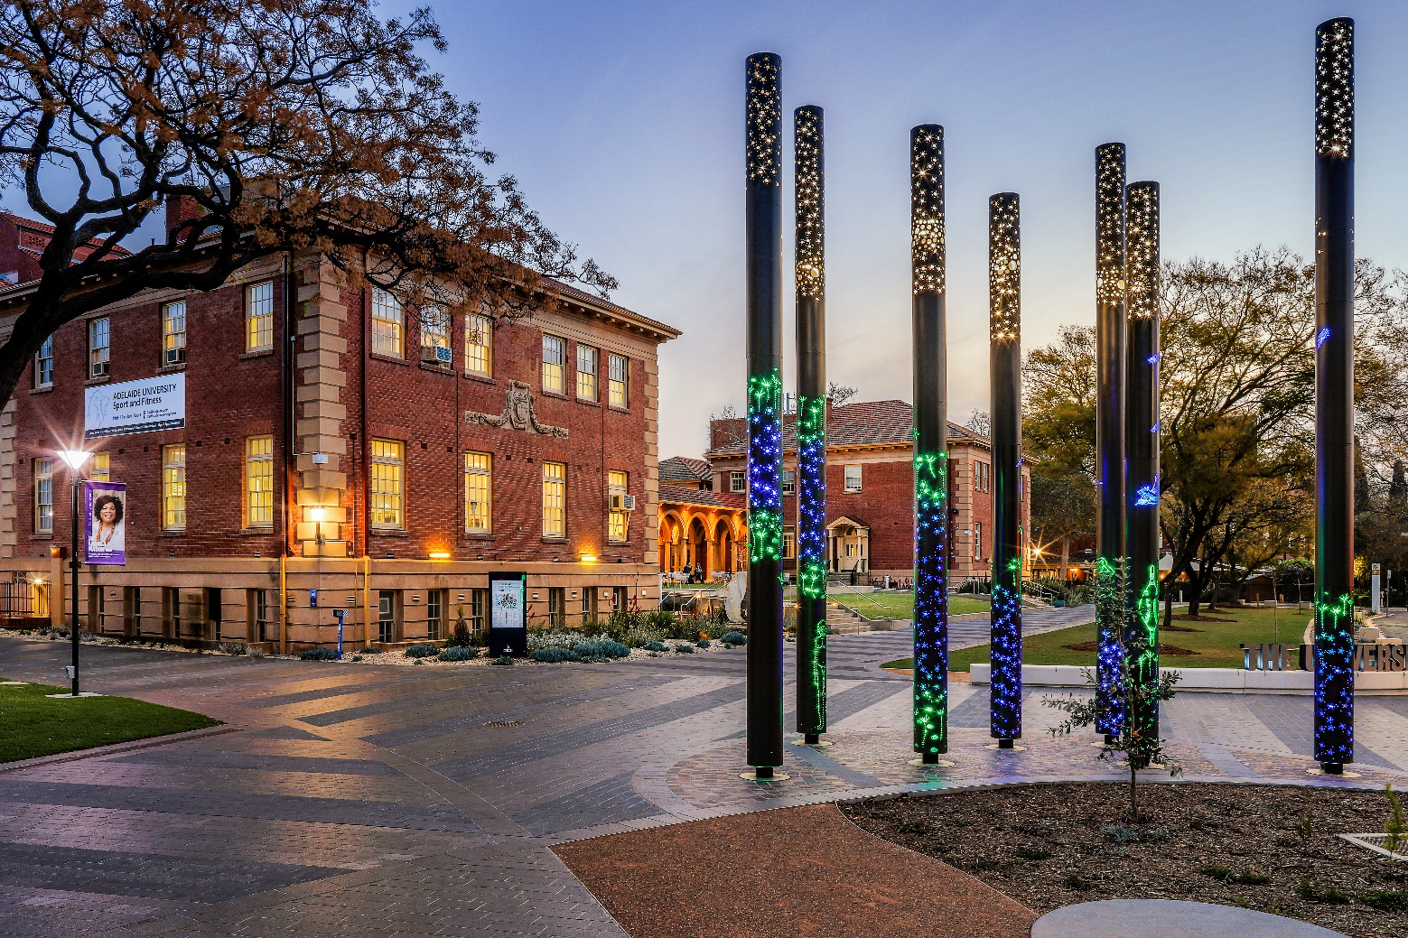

Student Mental Health and Wellbeing Strategy

Background
It is widely recognised that university students are a high risk population for mental ill-health and diminished wellbeing. The development of the Student Mental Health and Wellbeing Strategy 2021 – 2024 (‘The Strategy’) demonstrates the University’s commitment to supporting student mental health and wellbeing throughout their academic ventures.
The Strategy acknowledges that an essential foundation for students to realise their full potential is a commitment to a holistic approach to mental health and wellbeing, informed by social, economic, cultural, political and geographical factors. It aligns with the recognition that ‘wellness is not simply the absence of disease or infirmity’, and requires the spectrum of treatments, solutions and preventative strategies to wellbeing. The strategy acknowledges that there is no ‘one size fits all’ approach to supporting student mental health and wellbeing and recognition of the diverse needs, skills and experience of students is essential to the Strategy’s success.
The Strategy was developed utilising a tailored consultation process with staff and students to better understand the specific mental health and wellbeing needs of University of Adelaide students. This process enabled the identification of key action areas, goals and enablers to create a high-level framework to support student mental health and wellbeing.
It was endorsed by Academic Board in March 2020.
The Strategy commits to the provision of an annual progress report to the Vice-Chancellor’s Executive and Academic Board. This report highlights the key 2021 milestones and activities implemented towards improving student mental health and wellbeing, while acknowledging the challenges presented by COVID-19 and staff changes. The report also identifies next steps to generate engagement from the broader University community and a genuine commitment to student participation in creating real change.

Strategy launch
The Student Mental Health and Wellbeing Strategy was officially launched by Vice-Chancellor and President Professor Peter Høj AC on 26 October 2021. The event was attended by 70 University staff, students and key external stakeholders including distinguished guests Dr. John Brayley, South Australia’s Chief Psychiatrist; Ms Lyn Dean, Chief Executive of Wellbeing SA; and Dr David Kelly, South Australia’s Mental Health Commissioner.
The launch provided important opportunities to promote the Strategy to the broader University community and, importantly, to close the feedback loop for those who contributed their expertise as members of the Expert Panel, participated in consultations and provided essential feedback online.
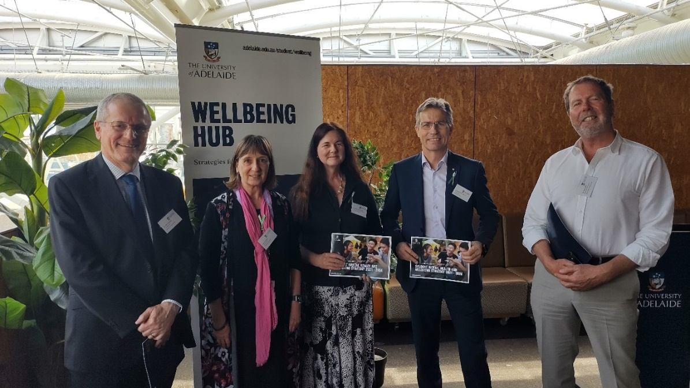
Pictured (L-R): Dr John Bradley, Ms Lyn Dean, Professor Jennie Shaw, Professor Peter Høj and Dr David Kelly.

Promotion
A dedicated webpage, hosted within the DASE website, was created to house the strategy, share progress on its implementation, promote opportunities for engagement and to act as a central contact point for the University community.
To generate awareness and interest, the Strategy was promoted via Staff and Student News, the Wellbeing Hub and the Student Wellbeing Operations Group (SWOG) which has 24 members including representation from the Adelaide University Union (AUU) and University Sports Association. The inclusion of external stakeholders at the Strategy launch was a purposeful way to generate interest and strengthen connections beyond the University.
In 2021 a key focus was to develop an implementation framework that would allow University students, staff and stakeholders to translate the high-level strategic framework into a practical roadmap for implementation.
Broad and extensive staff and student consultation was undertaken to ensure a holistic view and broad buy-in. In line with the Strategy, students from diverse backgrounds, including those who may be at greater risk of experiencing mental ill-health and those who would benefit from differentiated health and wellbeing approached, were invited to participate. The voices of both professional and academic staff were essential to capture the diverse experience of the University staff at various levels and across different areas of the University.

Student Focus Groups
Student Groups consulted | International students
 | Mature aged students
 | Gender diverse students
 | Students with disabilities, chronic illnesses or neurodivergent
 | Aboriginal and Torres Strait Islander Students
 | Postgraduate students
 | Students outside North Terrace campus and in rural/remote areas (Roseworthy, Waite, RAA, SAMHRI, AHMS)

Staff interviews
Staff consulted | Academic staff:  - Lecturers  - Course coordinators  - Higher Degree by Research supervisors  - Postgraduate coordinators
Professional and academic support services staff:
- Division of Academic and Student Engagement (DASE)
- Ask Adelaide
- Accommodation Services
- Counselling Service
- Disability Support
- Student Wellbeing
- International Students Support
- Elite Athletes
 | Student Engagement and Success
 | Human Resources
 | Wirltu Yarlu
 | Members from the Student Wellbeing Operations Group (SWOG), which is composed of professional staff from diverse areas of the University
Independent services for students:
- Student Care

This process has enabled the identification of priority themes for 2022/2023 and suggested activities under each of the Strategy’s five Action Areas:

University Culture
  - A cultural commitment to listening and responding to students.
  - Safe and respectful social, physical and online environments.

Learning Experience
  - Resourced and supported professional and academic staff.
  - Provision of clear and consistent information on support, resources and program expectations.

Community Awareness
  - Reduced stigma and an inclusive community attitude to mental ill-health.
  - Support for an early intervention approach to mental health and wellbeing.

Capacity Building
  - Mechanisms to ensure consistent, timely, University-wide information and responses in support of help seeking behaviour.
  - A University community with improved mental health literacy.

Service Delivery and Response
  - Differentiated mental health and wellbeing approaches for identified student groups.
  - Stepped care approach that offers a hierarchy of interventions to support individuals as their needs change.
- Governance
To ensure the successful implementation of the strategy, a mechanism with responsibility for monitoring, data collection and reporting will need to be identified. The possibility of a steering committee convened through the Division of Academic and Student Engagement (DASE) or identification of roles with key responsibility and accountability for each Action Area or nominated Action Area lead needs to be explored. The establishment of this group has been delayed due to significant role changes as part of the Organisational Sustainability Program (OSP).
Administration and executive support will be provided by Student Wellbeing Project Officers within Wellbeing & Access. The Student Health and Wellbeing team will ensure the priorities for 2022/2023, as identified through the extensive staff and student consultations, will be provided to leaders to help shape initiatives and activities. In line with the principles identified within the SMHW Strategy, the Student Health and Wellbeing team members will also lend their expertise in student participation to ensure the voices of students are front and centre.

Action Area Highlights
A range of activities and initiatives were delivered under the five Action Areas during 2021. Highlights include:

University Culture
  - Wellbeing Champions - The momentum generated by the Strategy launch provided a unique opportunity to invite expressions of interest from staff to create the inaugural Wellbeing Champions Network. Wellbeing Champions will assist in creating a safe, inclusive, supportive and respectful culture that is conducive to good mental health and wellbeing at the University of Adelaide. The network will be led by Professor Jennie Shaw, Deputy Vice-Chancellor and Vice-President (Academic), and is a key action for the University to achieve the vision of developing a culture that promotes and prioritises wellbeing. Twenty-six expressions of interest were received following the launch.
  - Student Wellbeing Operations Group – Twenty-four members with diverse representation across the University work together to coordinate wellbeing activities.
  - Wellbeing Warrior Volunteer Program – Commencement of the planning and development phase of this joint program with the AUU will provide meaningful volunteering and peer support opportunities for students motivated to positively impact on mental health and wellbeing.
  - Roseworthy Wellbeing Team - This volunteer group was established to support the delivery of wellbeing events and initiatives at the University’s Roseworthy campus. Supervised by staff at the campus, a fruitful working relationship is being established to facilitate better alignment with wellbeing campaigns and provision of resources to support delivery.

Learning Experience
  - Student Wellbeing in Learning and Teaching Community of Practice - This group was launched to bring together academics, professional staff and students to creatively address wellbeing in teaching and learning.
  - Being Well, Living Well – This online course provides opportunity for information to be embedded into existing course materials. A trial is underway with the School of Medicine through the Health Curriculum Innovation and Renewal Unit.

Community Awareness
  - Online Resources - Orientation events were cancelled due to COVID. As a result, online resources were developed and presented to highlight wellbeing resources available to students as part of a virtual orientation through the virtual platform, Events Air.
  - Safer Campus Community Week – Week 3 of Semesters 1 and 2 marks Safer Campus Community Week. Actions included messaging through student and staff news, social media engagement through messaging and competitions designed to incentivise participation in training programs, digital messaging and printed resources.
  - Health Week – Semester 1 campaign delivered events across four days. Events were based on consultations with students through social media channels. Semester 2 campaign delivered events across five days. This campaign also included both RUOK Day and National Suicide Prevention Day initiatives. Alongside workshop events, students were also supported to produce video materials for their peers normalising how to meaningfully ask about wellbeing. This is accessible for all on the Wellbeing Hub. The first “Mental Health First Aid, Conversations about Suicide” training program was also delivered to students. With Health Week and Sustainability Week falling in the same time period for the first time, Student Wellbeing worked collaboratively with Ecoversity to deliver a wellbeing focused session, building awareness and opportunities for cross-promotion and resource sharing.
  - HIV self-testing machines – Initial consultations commenced in October with SAMESH (SHINE SA and Thorne Harbour Health) to deliver HIV self-testing machines as part of a Federally funded pilot. The pilot progressed to installation in February 2022.
  - Poster and Hub screen campaigns – Campaigns included RUOK Day, Wellbeing Hub promotion, exam week stress and Being Well, Living Well promotion.
  - Stress Less – Student Wellbeing worked with the AUU to deliver an event as part of the Stress Less week activation.
  - Mental Health Awareness Month – Previously a week-long campaign, this campaign grew to a month’s duration nationally in 2021. A launch event was delivered and included 2 student speakers with lived experience. BAYTR, a lived experience organisation delivered an online workshop with 105 registrations. Student Health and Wellbeing provided $3380 to clubs and associations as part of a grant application program to deliver events designed to raise awareness of mental health and wellbeing. 22 events were held in total. Student Health and Wellbeing partnered with the Counselling Service to activate the Co-op space for the final week and provide access to evidence based resources and expert speakers on a range of wellbeing topics.

Capacity building
  - MATE Bystander Training – This training aims to resource others to step in and take action when witnessing unacceptable behaviour. 10 Training sessions were delivered in 2021 to:
  - SRC/AUU leaders
  - Aquinas College
  - ATIRA and Urban Nest
  - Uni Lodge
  - International Students
  - Mental Health First Aid Training – This training has seen keen interest from both students and staff. Five free sessions were delivered across the year with approximately 100 students who attended. Additional sessions were run for staff at a subsidised cost, enabling funding to support free student sessions.
  - Sexual Health Locker – The Safe Sex, No Regrets locker was launched in July 2021. 56 requests for condoms were made between July and 2021, distributing 560 condoms and information packs. Boxes containing 150 condoms have been provided to 5 student-registered clubs to distribute to their members.
  - Wellbeing Tips Newsletter – Newsletter began in March 2021 with 226 subscribers. 41 newsletters were sent out across the year and subscribers increased to 297 by year end. On average email opening rates are around 50% with approx. 25% clicking on contained resources.
  - Wellbeing Hub – There were 10,542 page views of the landing page, 8170 being unique across 2021. New pods and updated resources were also delivered, including focused COVID wellbeing material.
  - Being Well, Living Well - This year 139 students enrolled in this online course. The course is promoted to students who register for Counselling Support. Following registration, a screen detailing course modules and enrolment details is shown to promote awareness and encourage enrolment. Competitions were also trialled in collaboration with AU Sport to encourage engagement in the physical health modules.
  - Consent Matters – Promotion for engagement in Consent Matters included incentives offered through Safer Campus Community week competitions. An additional 56 enrolments resulted from this strategy.
  - Student social media team – The team consist of 6 student bloggers and a student social media editor. The team published 337 blogs in 2021. Following of the @ofastudentwellbeing page on Instagram grew by 290 followers across 2021 (2171 followers). The most popular posts centered on sexual health (condom campaign), back to uni preparation, first year tips and bystander awareness. Seven ‘takeovers’ were hosted with student groups from across the university including DIDA (Disability Illness and Divergence Association), Malaysian Students Association, International Peer Mentors, Pride Club, Totally Cooked and Sustainability Association. The team were also involved in a takeover of the main university social media page to promote Stress Less week and the wellbeing services on campus.
  - Welcome Back Festival – Wellbeing played an important role in the Welcome Back Festival including involvement in the conceptualisation, planning and deliver of the wellbeing stream of the Welcome Back Festival project. This included the research, planning, production and delivery of a printed booklet, “International Student Wellbeing Toolkit”, the administration of a Welcome Back grants program and online competition designed to support connection and engagement to community for returning international students. The planning of these initiatives occurred in 2021 with delivery in 2022.

Service delivery and response
  - Stepped Care Approach - The development of a Stepped Care model commenced, resulting in the identification of the Triage model to be incorporated into the new Organisational Sustainability Program structure.
  - Policy Review – A review of the Student Critical Incident policy and procedure was undertaken.
  - Student Collaboration - A collaboration with DIDA student group on service development has been established.
  - Suicide Prevention - Membership on Department of Premier and Cabinet SA Tertiary Education Suicide Prevention Group
  - Talk Campus - Launch of the International Student off-shore peer to peer mental health support initiative: Talk Campus.

Summary
The Strategy has seen strong interest and engagement across the University community and continues to represent a very important aspect of student engagement and success. Whilst the range of activities is broad and many are ongoing, the strategy provides a mechanism to represent the overarching aims and direction to understand, collectively, gaps and future areas for focus.

