Law Library self guided tour instructions





1. Download the GooseChase Android or iPhone app. 
2. Choose to play as a guest; or register for a personal account with an email, username, and password of your choice.

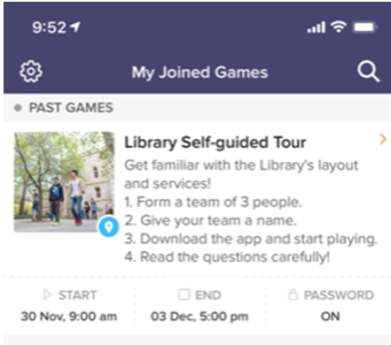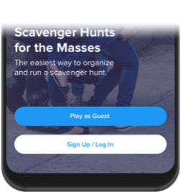

1. You will not find your game until the day of your tour. The game will go live on the tour date.
2. Tap the search icon and enter the name (**Law** **Library Self-guided Tour**), or game code (**3KBZJJ**).

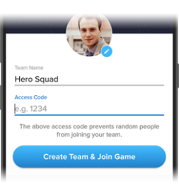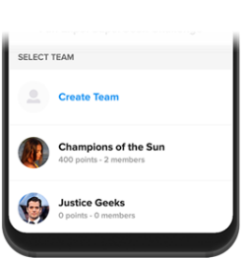

1. Create a team of 3-4 people or complete it yourself. Use your names as the team name, e.g. ‘Fred, Jiao and Yusef’s Team’.
2. Once in the game, you’ll be presented with the missions your team are attempting to complete. Mission types can include Photo/Video, Text, or GPS check in. To complete a mission, select it from the list and hit the “Snap

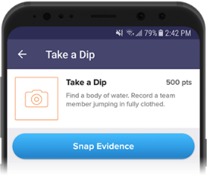

1. Make sure you’re completing missions accurately! (e.g. “take a picture of the comfy chair” means take a picture with a real chair, not a chair on a computer screen)
2. Using the navigation tabs, you can keep track of how you are doing via the activity feed and the leaderboard, see notifications from the game organizer or review (and resubmit) your previous submissions.

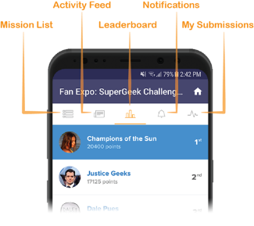

1. Most importantly, have fun getting to know the **Law Library!** Get really creative, interact with your fellow players and organizers and don’t be shy!