eCAF Help for Students

Once the University of Adelaide have lodged your application, the government will send an email to your University account with a passkey. Navigate to the eCAF site, and select the green “sign in” button.
NOTE: If the button is black, select “are you a student” to enable the student login
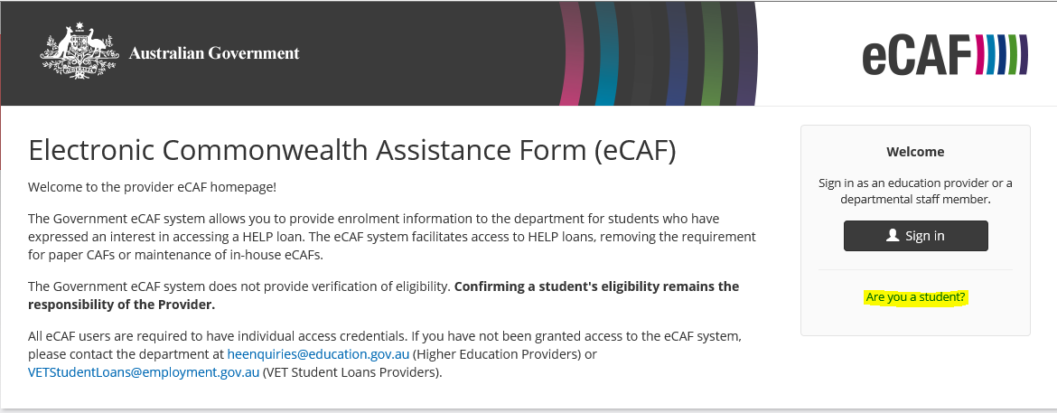
The student login button is green:
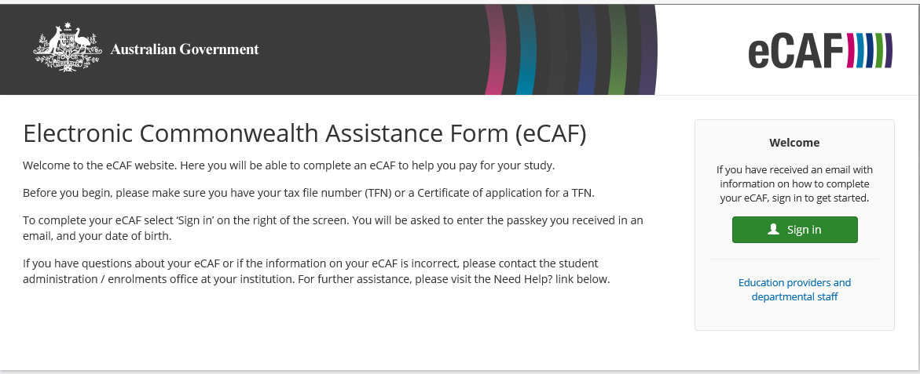

To login, Use the passkey that was emailed to your student email address, and your date of birth.
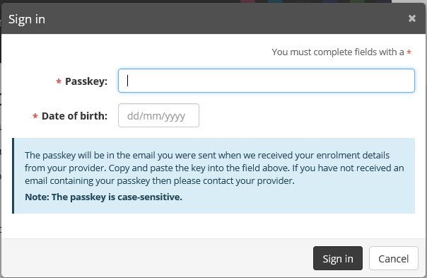
This will take you to your OS-Help application details page:
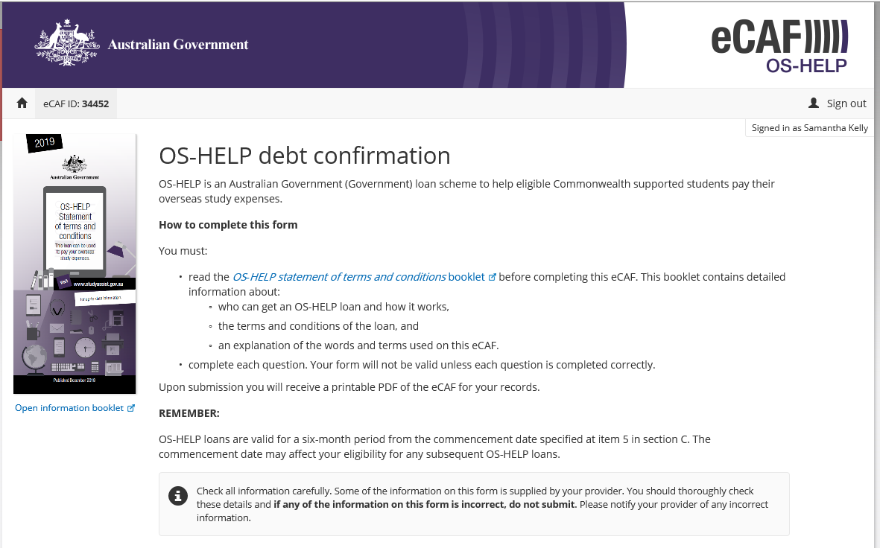

You will be unable to modify any of the form data that has already been filled in with data supplied by the University:
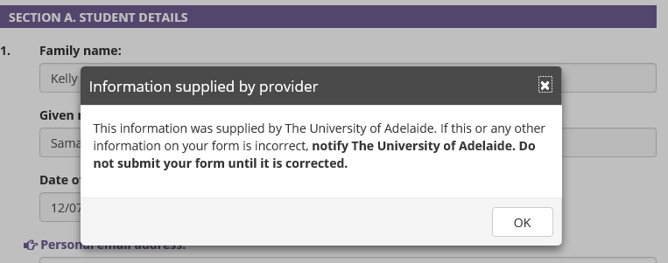
Verify your email address:
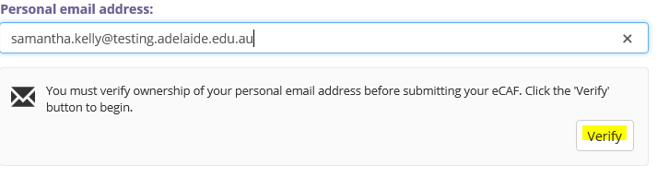
Input your tax file number (TFN):
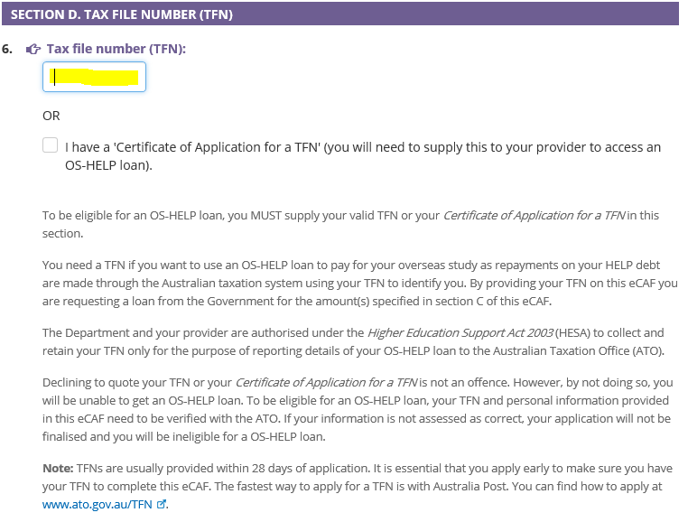

Select submit once you have verified your email address and input your TFN:
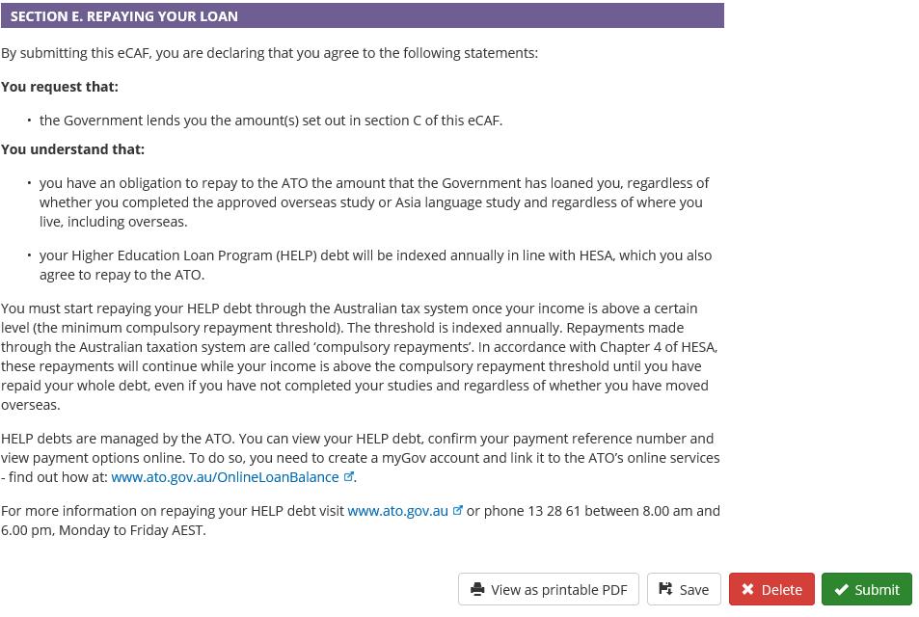

Check the terms and conditions box:
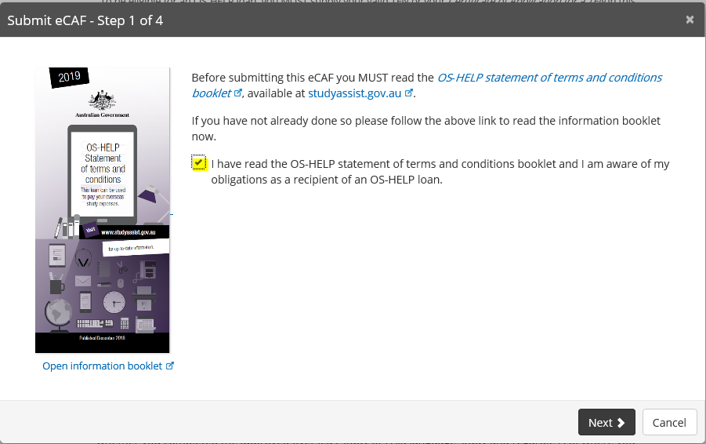

The system will attempt to validate your TFN. You can skip this step if the validation is taking too long.
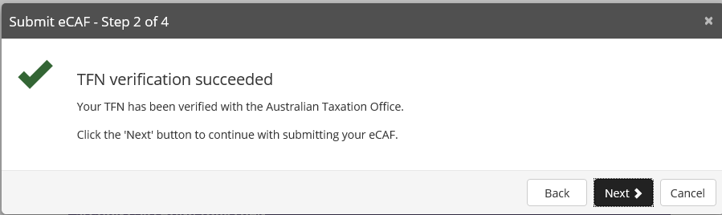

Check all the boxes on the step 3 screen:
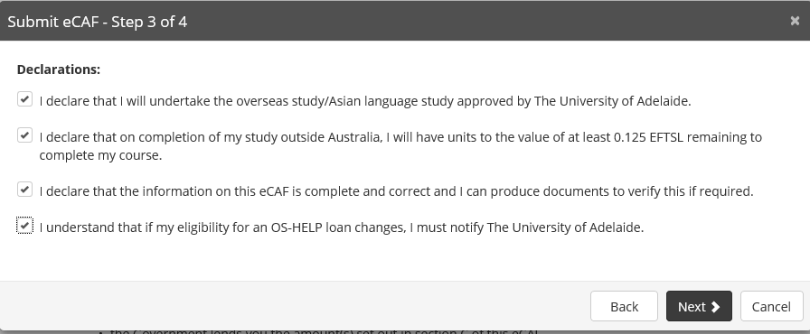

On the Step 4 screen, scroll to the bottom and check the “I have read and understood the above” and select “submit”:
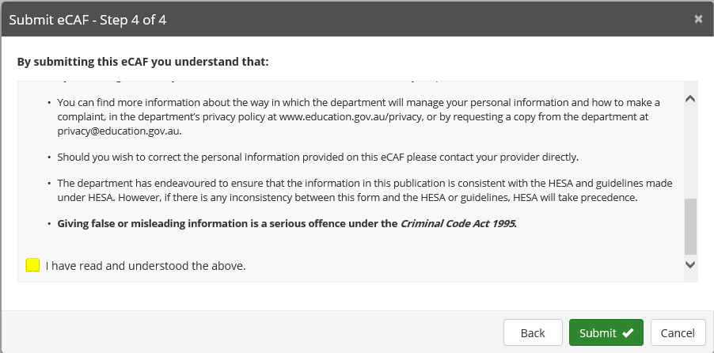

Confirm submission:
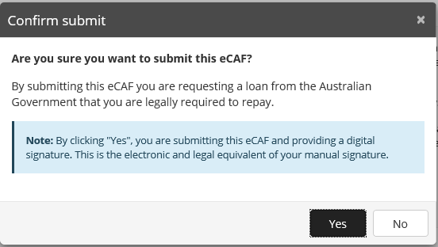

You will be notified of the submission status:
