Vitamin A
‘Why weren’t we told this long ago?’

Access May 2010 Michael Latham on Vitamin A here
Access October 2014 IJE John Mason, Ted Greiner et al on Vitamin A here
Access November 2014 John Mason, Ted Greiner et al on Vitamin A here

Graham Lyons writes:
Congratulations to John Mason and his co-authors for ‘Vitamin A policies need rethinking’ in the International Journal of Epidemiology (1) and their commentary in World Nutrition (2) . This builds on Michael Latham’s incisive ‘The great Vitamin A fiasco’ pubished in WN in 2010 (3). These authors discuss the problems with the vitamin A capsule programme and argue persuasively for its curtailment.

A renewed paradigm

My background is in farming, and I consider the only realistic, sustainable approach to improving human nutrition and health at the population level is through the food system. A renewed agricultural paradigm embraces the provision of nutritious, diverse foods, moving beyond a sole focus on trying to increase the yield of a few staple crops (4).

Indeed, this can be taken a step further: the key to sustainable, nutritious food systems, especially for farmers who cannot afford commercial fertilisers, is to re-establish agricultural ecosystems which are closer to the natural ecosystems they replaced. This is especially applicable to Sub-Saharan Africa (5,6).

The food system approach lends itself well to alleviating micronutrient deficiencies. Vitamin A deficiency disorders are often and perhaps usually accompanied by deficiencies of iron, zinc, selenium, and B vitamins, and these will not be addressed by a reductionist vitamin A capsule programme. Furthermore, the provision of diverse foods or condiments, in some cases biofortified, and process-fortified if required (for example, the successful iodised salt programme), enables the expression of beneficial micronutrient interactions (7). Biofortified high-iron beans and high beta-carotene maize and cassava have recently been released in Africa by HarvestPlus ( www.harvestplus.org ). Moreover, the Drumstick tree (Moringa oleifera) is an outstanding natural biofortifier of beta-carotene, selenium and sulphur (8).

Work in the Pacific and Indonesia

Since 2006 I have been involved in food system research and development in the Pacific and Indonesia, initially focused on high beta-carotene orange-fleshed sweetpotatoes and yellow bananas (funded by HarvestPlus and the Australian Centre for International Agricultural Research) and more recently on nutritious local leafy vegetables (ACIAR: see our “Top 12” nutritious leafy vegetables via this link: www.aciar.gov.au/News2013July). The importance of these food plants as inexpensive sources of b-carotene was noted by Michael Latham (2010) and John Mason and his co-authors (1, 3). An intervention study in Mozambique found that production and consumption of orange-fleshed sweetpotatoes increased serum retinol concentrations in children (n = 741) (Low et al, 2007). The bioavailability and bioconversion of beta-carotene in these foods can be increased by cooking with or adding a healthy oil such as virgin coconut oil or red palm oil.

Education and access to suitable germplasm/planting material is required for successful implementation of a food system strategy to improve food and nutrition security. It is such activities that agriculture and health extensionists need to be involved with, not handing out pills or capsules every 4-6 months.
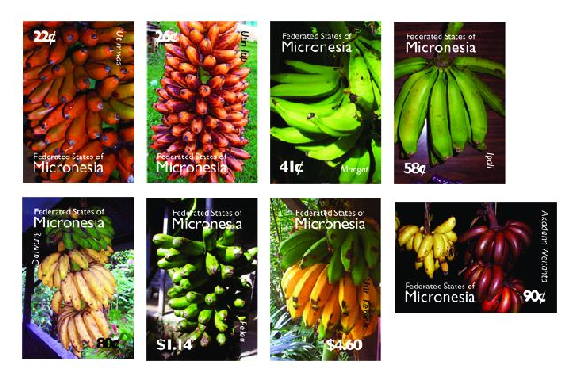
The Federated States of Micronesia valorises the work of Lois Englberger and many others, by this set of postage stamps celebrating the varieties of banana that naturally protect against vitamin A deficiency

In my experience, particularly in the Solomon Islands, this is the work they enjoy most, and such programmes resonate with villagers and smallholders. I have been fortunate to work with the great nutritionist, educator and communicator Lois
Englberger, founder of the Go Local movement (9), and Mary Taylor, who established the Secretariat of the Pacific Community’s germplasm bank, the Centre for Pacific Crops and Trees in Suva, Fiji. Lois related the story of the delight of women who attended our Go Local workshops on Makira Island in 2007 in learning of the nutritional value of their indigenous yellow and orange bananas. ‘Why weren’t we told this long ago? Now we are proud of our bananas!’ There is now an annual banana festival on this island, which is home to around 130 banana varieties.

The need for increased production and consumption of nutritious local vegetables and fruit is greater than ever, and not just due to population increase. The pandemic of obesity, diabetes, hypertension, heart disease, various cancers and other disorders and diseases, has overtaken micronutrient malnutrition in terms of health, medical and economic impact on humans. The Global Fruit and Vegetables for Health Initiative was launched in 2003 in Geneva by FAO and WHO in recognition of the importance of fruit and vegetable consumption for health. The first workshop was held in Kobe, Japan in 2004. I was fortunate to represent ACIAR at the most recent FAO/WHO workshop with this theme in Nadi, Fiji in October 2014. Attendees included health, agriculture and education officials from most Pacific countries.

There is an urgent need to move resources from simplistic, expensive, reductionist medicinal dosing strategies to comprehensive food-based and food system-based approaches to address food and nutrition security. I congratulate World Nutrition for addressing this compelling issue. This is just the beginning.

Graham Lyons
University of Adelaide, South Australia
Email: graham.lyons@adelaide.edu.au

References:

1 Mason J, Greiner T, Shrimpton R, Sanders D, Tukich J. Vitamin A policies need rethinking. International Journal of Epidemiology 2014; doi: 10.1093/ije/dyu194.
2 Mason J, Greiner T, Shrimpton R, Sanders D, Yukich J. Development. Malnutrition. Vitamin A. Let food be our medicine. World Nutrition 2014; 5(11): 940-952.
3 Latham M. The great vitamin A fiasco. World Nutrition 2010; 1, 1: 12-45.
4 Graham RD, Welch RM, Bouis HE. Addressing micronutrient malnutrition through enhancing the nutritional quality of staple foods: principles, perspectives and knowledge gaps. Advances in Agronomy 2001; 70: 77-142.
5 Christophersen OA, Lyons G, Haug A, Steinnes E. Selenium. In Alloway BJ (ed). Heavy Metals in Soils: Trace Elements and Metalloids in Soils and their Bioavailability. Springer, Dordrecht, 2013: pp 429-463.
6 Sanginga N, Woomer PL (eds). Integrated Soil Fertility Management in Africa: Principles, Practices and Developmental Process. Tropical Soil Biology and Fertility Institute of the International Centre for Tropical Agriculture. Nairobi, Kenya, 2009.
7 Lyons GH, Stangoulis JCR, Graham RD. Exploiting micronutrient interaction to optimize biofortification programs: the case for inclusion of selenium and iodine in the HarvestPlus program. Nutrition Reviews 2004; 62: 247-252.
8 Lyons GH, Gondwe C, Banuelos GS, Zambrano MC, Haug A, Christophersen OA. Drumming up selenium and sulphur in Africa: Improving nutrition with Moringa oleifera. In Banuelos GS, Lin Z-Q, Yin X (eds) Selenium in the Environment and Human Health. CRC Press, Boca Raton, USA, 2014: pp 91-92.
9 Englberger L, Lyons GH, Foley W, Daniells J, Aalbersberg W, Dolodolotawake U, Watoto C, Iramu E, Taki B, Wehi F, Warito P, Taylor M. Carotenoid and riboflavin content of banana cultivars from Makira, Solomon Islands. Journal of Food Composition and Analysis 2010; 23(6): 624-632.

Low JW, Arimond M, Osman N, Cunguara B, Zano F, Tschirley D. A food-based approach introducing orange-fleshed sweet potatoes increased vitamin A intake and serum retinol concentrations in young children in rural Mozambique. Journal of Nutrition 2007; 137(5): 1320-1327.

Lyons G. Vitamin A. ‘Why weren’t we told this long ago?’
[Feedback]. World Nutrition December 2014, 5, 12, 1125-1126

