Press Release
Two continents, one project
Australian project partner visits the Münster University of Applied Sciences
Münster/Adelaide (8 June 2010).
What are the success factors for the relationships between researchers and enterprises? How does co-operation change with the development of experience and strategic alignment? An international research project being conducted by the Münster University of Applied Sciences and the University of Adelaide wants to find answers to these questions.
As part of the project, the Science Marketing group at the Münster University of Applied Sciences hosted a visit by Greg Macpherson from the University of Adelaide. Mr Macpherson represented the Australian research team and brings university industry relationship experience from the commercial development company, Adelaide Research & Innovation. This adds practical experience to the research project, which will help to ensure the research output carries valuable suggestions for researchers and industry. Mr Macpherson’s experience with technology transfer offices in Europe and Australia will help to promote international benefits of the research.
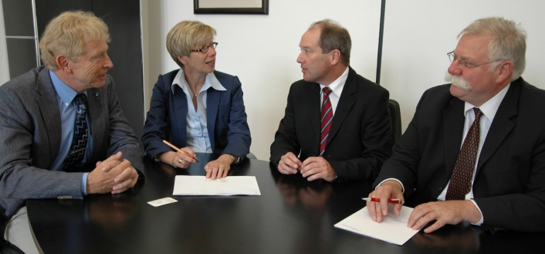
From left, Vice President, Research, Prof. Dr. Richard Korff. President Prof. Dr. Ute von Lojewski, Greg Macpherson and Prof. Dr. Thomas Baaken, head of Science Marketing.
At a meeting with the President of the University Prof. Dr. Ute von Lojewski and the Vice President for Research, Prof. Dr. Richard Korff, Mr Macpherson complimented the Münster University of Applied Sciences’ proactive engagement with enterprises in the region and the strategically aligned partner program with small and medium enterprises. This provided ideas that he would take home to Adelaide.
The project was initiated by Dr Carolin Plewa, Discipline Leader, Marketing, in the University of Adelaide Business School and won the funding from the German Academic Exchange Service (DAAD) and the Group of Eight, representing the major research universities in Australia. Dr Plewa is coordinating the project and expects results in February 2012.
While the project studies the formation of relationships, a very positive relationship has already been formed, that between Münster and Adelaide.

This press release has been prepared from the Münster University press release, paraphrased from the German and edited.

