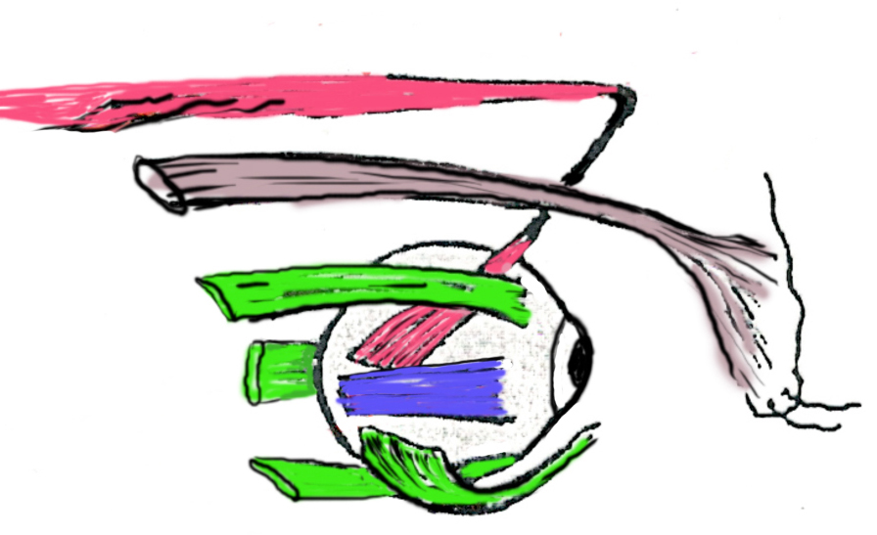
Applied Anatomy Workshop for Ophthalmology Trainees
One-day practical exam trial with discussion/revision
This workshop is offered twice a year
Semester 1 (Saturday 3rd February, 2018)
Semester 2 (Saturday 6th October, 2018)

The applied anatomy workshop for ophthalmology trainees is a one-day workshop set up as a trial exam. The stations utilise museum pots, dissected cadavers and images. The trial is integrated with discussion of the theoretical background. The topics include the bony orbit and skull, cranial cavity, venous sinuses, eyeball, extraocular muscles, cranial nerves, blood vessels, lacrimal apparatus, eyelid structure, neuroanatomy, autonomic nervous system, face and neck.

Workshop material: candidates will receive handouts including a question paper with images of the displayed specimens and available spaces to record their answers and the comments following the discussion/revision feedback.

Venue: Adelaide Medical School, University of Adelaide, South Australia.

Fees: $660 inclusive of GST.

Lunch and refreshment included.

This workshop is for educational training and has No industry sponsorship association.

For Registration form and further information, contact Associate Professor Mounir Ghabriel, mounir.ghabriel@adelaide.edu.au, (+618) 83135481).

-----------------------------------------------

