Academic oral presentation skills teachers’ manual
Suggested lesson format

Aim
The aim of this video is to provide a teaching tool which will help lecturers and teachers to discuss oral presentation skills with their students by watching an example of a good and a poor presentation. At the lecturer’s discretion, students will also have the opportunity to stand up and speak for a short time in front of their peers, in order to overcome the initial hurdle of speaking in front of an audience and gain confidence in a non-threatening environment. If you want to include time for student presentations, the session will take two hours, or it could be taught over two shorter lessons, depending on timetabling. Without the practical component, the session can be taught in one hour, finishing at stage 9.

Photocopiable materials are included and these can be made into a complete handout for each student. The components are (1) Presentation 1 student’s handout; (2) Presentation 1 assessment; (3) Presentation 2 student’s handout; (4) PREPARE; (5) Use of PowerPoint and other slides; and (6) Your Oral Presentation. These materials are also available at www.adelaide.edu.au/english-for-uni.

The following teaching stages are suggested:

1. Elicit problems students have with presentations.

2. Discuss what makes a good presentation.

3. Draw students' attention to the Presentation 1 Student's Handout about the French and Russian Revolutions and the Presentation 1 Assessment page. Play the video, which leads in to the example of a poor presentation. NB Start at 0:45 seconds to go straight to the first presentation.

During the first presentation, students should look for at least 20 problem features, in the areas of presenter, content, use of PowerPoint and handout. They should rate the presentation using the Presentation 1 Assessment page. A separate list of all the problem areas is available on page 3 of this manual for teachers' use (see Problems with the Poor Presentation).

4. Pause the video for student feedback. Discuss how the presentation could have been improved.

5. Consider the Presentation 2 Student's Handout on Transformational Leadership with the group. Continue with the video and watch the example of a good presentation.

6. Pause or exit the video for more discussion.

7. End the video. At this point, discuss the PREPARE acronym.

8. Consider the items on the Use of PowerPoint and other slides page.

9. Ask the students to think about an upcoming talk they may have to do, using the page entitled Your Oral Presentation.

For a 1 hour session, it is suggested that you finish at this point and, if you are including the practical component, ask students to prepare a short talk for the next class (see suggestions at stage 10), using an overhead transparency. The next session will then start at stage 11.

For a 2 hour session, continue from stage 10.

10. Give the students 5 minutes (or more, depending on the size of the group) to prepare a very short presentation. This could be a short talk about the topic of an upcoming oral presentation or a recent essay, or it could be a brief introduction about who they are, where they are from and what they are studying.

11. Ask each student to deliver their talk, and provide feedback from yourself and at least one other student.

12. End with a group discussion of the points raised in the feedback. These should be general points that apply to the whole group, rather than comments targeting an individual (unless these comments are very positive).

Problems with the poor presentation

PowerPoint
Size of font
Colour of font
Spelling
Punctuation
Capitalisation
Inappropriateness of many images, and mistakes with the flags
No acknowledgement of where the flags are from
Ignorance of how to use technology
Inappropriate background for the slides
Annoying final slide

Presenter
Untidily dressed
Arrives still eating a sandwich
Starts by apologising
Reads from slide
Unrehearsed – cannot pronounce names
Bad timing
Eye contact avoided or overdone
Mobile phone should be turned off
Does not understand content
Does not relate to audience
Speaks with his back to the audience
Stands in front of the projector
Speaks too quickly at times
Boring
Ill-equipped – asks for a tape recorder which is not there

Content
No background or introduction to talk
No links or structure
Main points not identified
Unclear – who or what is he talking about?
Inaccurate and uninformed – 17X9 instead of 1789
Pictures may be insulting to French and Russians
Wrong flags (not French, but Luxembourgeois. Russian flag not appropriate to the Bolshevik revolution)
Informal language
Plagiarism and lack of references

Handout
Irrelevant
Non-academic
Totally uninformative
Untidy
Not enough copies
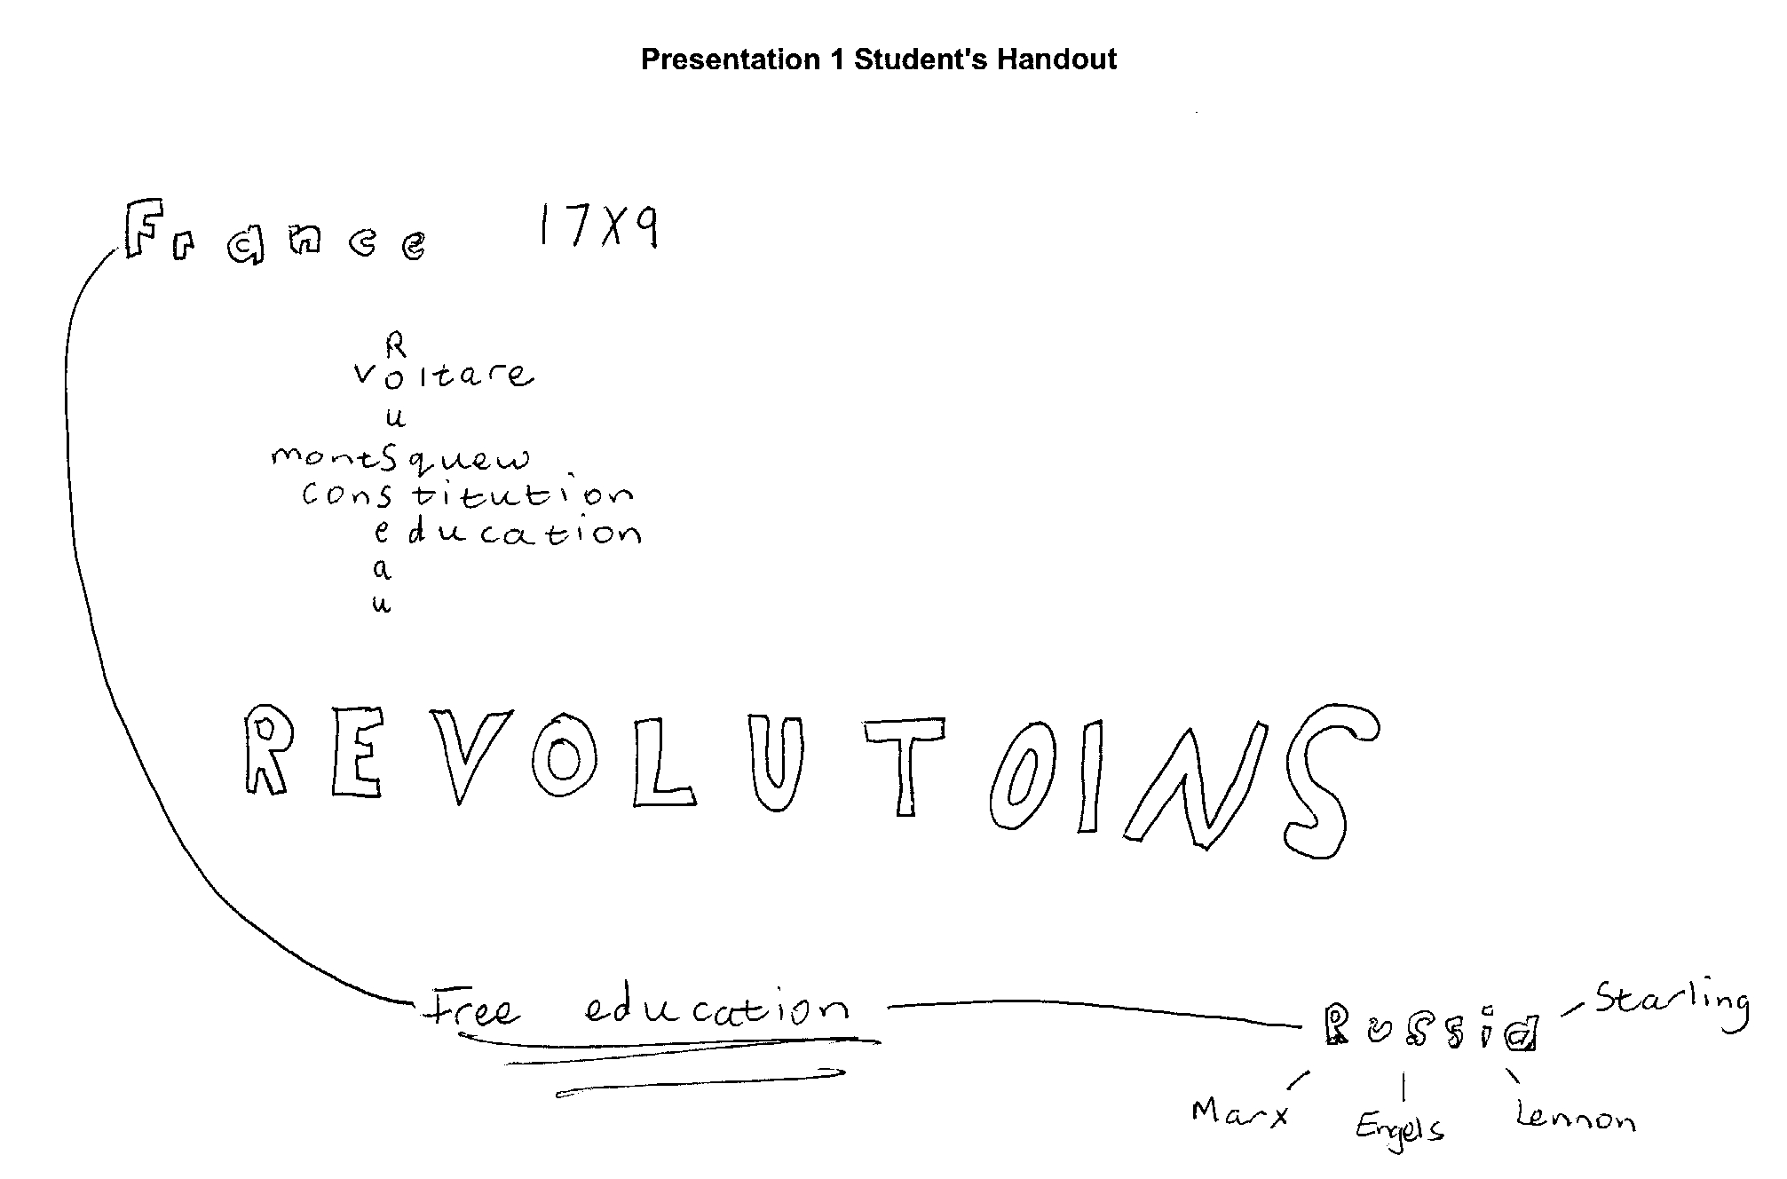

Presentation 1 Assessment

Presenter | Excellent | Satisfactory | Poor
Pleasant manner
Confidence
Enthusiasm
Fluency
Speed
Volume
Timing
Eye contact
Humour
Avoidance of unnecessary interruptions
Knowledge of subject
Response to questions
Use of notes
Use of slides
Content | Excellent | Satisfactory | Poor
Introduction
Structure and links
Identification of main points
Clarity
Accuracy
Originality of material
Appropriateness of language

PowerPoint | Excellent | Satisfactory | Poor
Size of font
Colour of font
Background of slides
Spelling
Punctuation
Capitalisation
Overall effect
Use of sound
Use of images
Use of technology
Handout | Excellent | Satisfactory | Poor
Relevance
Academic style
Usefulness

Presentation 2 Student's Handout

Transformational Leadership
presented by Prisca Were

Leadership
- The ability to influence others to achieve organizational goals (Bartol et al., 2003, p. 389).
- “the projection of personality . . . that makes other people do what you want them to do” (Megginson, Mosely, & Petri, 1989, p. 385).

Transformational leadership
The process of defining the objectives of an organization and rallying and empowering followers to accomplish these objectives (Yukl, 1994). 4 dimensions:
- Idealized influence
- Individual consideration
- Intellectual stimulation
- Inspirational motivation (Bass, 1985, as cited in Yukl, 1994)

Characteristics of transformational leaders
- Risk takers
- Network builders
- Inspirers of trust who also trust others
- Visionaries (Lussier & Achua, 2004; Yukl, 1994; Kreitner & Kinicki, 1992)

Impact of transformational leadership in the Teachers' Service Commission, Kenya
1965 - 1998: Autocratic/laissez-faire leadership
1998 - 2006: Transformational leadership, marked by
- Creation of the TSC logo
- Outlining of the Mission/Vision statements
- Drawing of the 1st ever strategic plan
- Drawing of a service charter
- Renewed focus on staff training
- Computerization of the systems
- Restructuring of the organization

Conclusion
Because transformational leaders have foresight and are able to anticipate change as well as challenge, they are able to ensure that their organizations stay afloat in the advent of competition. This has proved to be the case with the TSC.

“The task of the leader is to get his people from where they are to where they have not been.” Henry Kissinger.

References
Bartol, K., Matthews, G., & Martin, D. (2003). Management: A Pacific rim focus (enhanced edition). Boston: McGraw-Hill.
Kreitner, R., & Kinicki, A. (1992). Organizational behavior. Boston: Richard D. Irwin, Inc.
Lussier, R. N., & Achua, C. F. (2004). Leadership: Theory, application, skill development (2nd ed.). Sydney: Thompson.
Megginson, L. C., Mosley, D.C., & Petri, P.H. (1989). Management: Concepts and applications (3rd ed.). New York: Harper and Row publishers.
Yukl, G. (1994). Leadership in organizations (3rd ed.). New Jersey: Prentice Hall.
PREPARE

A good speaker should prepare carefully for their talk and be:

P urposeful
R elevant
E nthusiastic
P roficient
A cademic
R eliable
E ngaging

Purposeful Indicate the structure of your talk and give your audience a clear sense of direction.

Relevant Make your material relevant to the topic and to the audience.

Enthusiastic Show that you enjoy your subject.

Proficient Maintain control throughout your talk by researching and preparing your material carefully. Practise using the equipment in advance, and be ready to answer audience’s questions.

Academic Use formal language and ensure that the style and content of your slides are appropriate.

Reliable Provide sources for your information. Include references when necessary and be prepared to give your audience a short bibliography on request.

Engaging Keep your audience's attention by using good eye contact and delivering your material as a talk, rather than reading from your notes or reciting from memory. Use unobtrusive cards for your notes so that they do not hide your face.

Use of PowerPoint and other slides

- Face the audience, not the screen.
- Point with the mouse on the computer, or with a laser pointer on the screen.
- Stand to one side, so people can see the screen.
- Give the audience time to read your slides.
- Make sure your font is large enough to read from a distance (e.g. Arial size 22 for PowerPoint).
- Use a font colour which contrasts strongly with the background of your slides.
- Have a maximum of about 40 words on each slide/transparency.
- Use only relevant content.
- Design the slides to support what you are saying, not to hide it.
- Include references in the text of your slides where necessary, and provide a reference list at the end of your slides.
- Avoid distractions such as moving images on your slides.
- Use simple transitions between slides.
- Use a simple background, and stick to the same background for each slide.

Your Oral Presentation

Some questions to consider about your presentation:

Content and structure
- What is your topic?
- What are your key points?
- How can you structure your talk?
- Does your introduction show the key points and structure clearly?
- How can you make an essay, or detailed notes, into prompts for your talk?

Slides and handouts
- Do you need any PowerPoint slides?
- Does the order of the points on your slides match the order of the points in your talk?
- Do you need to prepare a handout?
- What references should you include on your slides or handouts?
- When should you give the audience your handout?

Audience and delivery
- Can you visit the room before the presentation, in order to check the equipment?
- What do you know about the audience?
- Is humour acceptable?
- How is eye contact best maintained?
- How can you control your voice?
- How can you overcome nervousness?
- How can you make sure you keep to time?
- Are you well prepared?

