Tenses in academic writing
Writers use tenses to give a particular meaning. The writer might be trying to emphasise the currency, regularity or even ownership of an idea. Some tenses are therefore used more than others in academic English.
 | Simple | Perfect | Continuous/Progressive | Perfect Continuous/Progressive
 | - | have + past participle | be + -ing | have + past participle  + been + -ing
Present | claim/claims | has claimed | am/is/are claiming | has/have been claiming
Past | claimed | had claimed | was/were claiming | had been claiming
Future | will claim | will have claimed | will be claiming | will have been claiming
The simple tenses are used for events which are immediate facts (or strong predictions in the future), complete or unchanging.
The perfect tenses are used to show the prior nature of an event in relation to some other point in time.
The continuous/progressive tenses are used for an event which is not complete, or is temporary or changing. (N.B. The word 'continuous' is used in British and Australian grammar books, while US grammar books use the word 'progressive' for these tenses.)
Here is a timeline to show you some tenses commonly used in academic writing: Simple and perfect, present and past tenses are used most in academic writing.
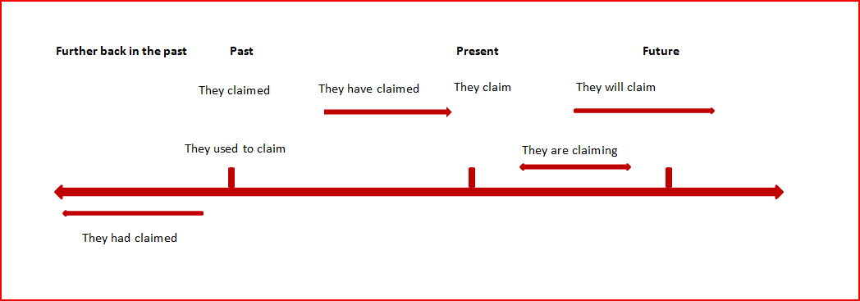
Present simple
- A general principle
Talent shows usually allow people to demonstrate their creative abilities.
- Someone's opinion
Professor Grahamarian thinks that talent shows are important.
- The results of an experiment
The judges' scores show that X is the clear winner.
- A habitual action in the present
People nearly always feel nervous before they perform on stage.
- A theory
Bobby Dylan's theory about talent contests is that one should not judge by appearances.
- A claim
Bobby Dylan claims that talent shows are the best way for people to become famous.
- A fact
Talent shows are exciting.
Past simple
- What happened
There were two acts. Prince Wolfgang won the competition.
- What happened in the past but is different now
In the past, shows were simpler.
- Ideas that were held in the past but are no longer held
People thought that talent contests were bad.
Used to is also used to compare the past to the present
People used to win smaller prizes. [This implies that the situation has changed.]
Present perfect
- Something that has changed over time
Recently, talent contests have become bigger and more glamorous.
- Recent research and its present impact
Recent research has shown that talent contests can make people nervous.
Tenses less used in academic writing
Generally, academic writing is based on research or theories that already exist, have already happened, or refer to a current event or view. This means that the various forms of the future are less likely to be used in essays, although they might be used in reports.
- ‘going to' future: They are going to research this next year.
- future simple: They will research this next year.
- future continuous: They will be playing some music by Mozart.
- future perfect: At the end of August they will have had over 150 rehearsals.
The continuous/progressive forms are less common in academic writing because they indicate something temporary.
- present continuous/progressive: They are researching this now.
- present perfect continuous/progressive: They will be playing some music by Mozart.
- past perfect continuous/progressive: They had been researching this for many years before they found any significant results.
- future perfect continuous/progressive: By the end of August we will have been playing music together for three years.
The past perfect situates one activity in the past before another activity. It is sometimes used in academic writing.
- past perfect: They had researched this for many years before they found any significant results.
- past perfect continuous/progressive: They had been researching this for many years before they found any significant results.
The difference between the past perfect and the past perfect continuous is that the continuous form puts more emphasis on the length of the activity.
Stative verbs
Some verbs are called ‘stative verbs'. These are verbs that refer to states or preferences rather than to physical actions. They are not normally used in continuous or progressive forms. Here are some examples:
Stative verbs
agree | involve | realise
appear | know | recognise
believe | like | resemble
consist | love | seem
constitute | mean | understand
doubt | need | want
hate | own | weigh
include | prefer | wish
e.g. We say, They agree rather than They are agreeing.
(Visit the Perfect English Grammar website for a comprehensive list of stative verbs and explanations about how to use them.)
Consistency of verb tenses
Jumping from tense to tense can make reading difficult and confusing. Within a sentence there needs to be a logical sequence to the ideas or events. From sentence to sentence within a paragraph there also needs to be a logical relationship.
Incorrect: The study ended suddenly because many of the participants have moved away.
This is confusing because the writer starts by looking back at the past (ended) but then changes their perspective to the present perfect (have moved).
Correct: The study ended suddenly because many of the participants had moved away.
This is better, because all the action is situated in the past.
Citing sources and verb tenses
When you are reporting on research in the past, then a past tense is mostly used.
e.g. According to the findings by Henderson (2008), all the interviewees reported negative side effects from the drug.
However, in a literature review or a paragraph that is trying to stress that certain ideas are still relevant, the present perfect tense may be used.
e.g. Even though linguists have argued that language learning is an incremental process, young children have shown that risk taking and game playing speed up the process (Chen 2009; Brown 2003).
In addition, if research results are still meaningful then the present simple is used.
e.g. The data collected from Green's (2004) research suggest that exposure to stress reduces language fluency. (N.B. data can be either singular or plural.)
Subject/verb agreement
In English, subjects and verbs should agree.
Present simple. All the verb endings are the same in regular verbs, except in the third person singular (he/she/it). Verbs after he/she/it add -s or -es.
I/you/we/they | claim | research | deny
he/she/it | claims | researches | denies
Most verbs in the present simple add –s in the third person.
-es is added to verbs ending in -o, -ch, -sh, -ss, -tch, -x and -z.
Verbs ending in a consonant + y (e.g. deny, rely) change the y to an i and add -es.
When there are several nouns, check which is the subject of the verb to see how it agrees. The subject may not be the word closest to the verb.
e.g. The use of these procedures is recommended by the university. (In this example, it is the word use which is the subject.
e.g. Recent discoveries in the area have led to an improvement in treatment.

Noun + noun = plural verb
e.g. A girl and a dog were sitting on the library steps.
Difficult cases
- The number of + singular verb. The number of cases is declining.
- A number of + plural verb. A number of people are waiting for their results.
There is/There are
Turn the sentence round to see if you need there is or there are.
e.g. There is an excellent article in this journal = An excellent article is in this journal.
e.g. There are some excellent articles in this journal = Some excellent articles are in this journal.
Future tenses
It is sometimes hard to choose which future tense to use in English, as the differences in meaning can be very small. For example, the future continuous is more informal than the future simple.
They will leave tomorrow. (prediction)
They leave tomorrow. (formal)
They are leaving tomorrow. (planned event; arrangements already made)
They are going to leave tomorrow. (planned event; focuses on intention)
They will be leaving tomorrow. (less definite; informal)
They will have left before you arrive tomorrow. (situates the event before another event)
Aspect – for advanced grammar lovers
The word ‘tense’ is often used to cover the two terms ‘tense’ and ‘aspect’. ‘Tense’ refers to the time when something happens (present, past or future). ‘Aspect’ refers to how we experience the action (as something which is complete, ongoing or happening before another action). In English we usually refer to three aspects: simple, perfect and progressive/continuous.

T  i  m  e | Aspect
 |  | Simple | Perfect | Progressive/  Continuous | Perfect Progressive/  Continuous
 |  | Ø | have + past participle | be + -ing | have + past participle  + be + -ing
 | Present | play/  plays | has/have played | am/is/are playing | has/have been playing
 | Past | played | played | was/were playing | had been playing
 | Future | will play | will have played | will be playing | will have been playing

The simple aspect is used for facts or strong predictions.
e.g. I work in the maths department.

I cycle to the university every day.
I have an exam next week.
I submitted my assignment last week.
I will study engineering next year.
The perfect aspect is used to indicate that something happened before another point in time and is still relevant at that point in time.
e.g. I have submitteed my report.
She had left before we arrived.
He will have graduated before we even enrol.
The progressive aspect is used for an event which is not complete, or is temporary or changing.
e.g. He is busy entering the data. (= at the moment)
They are getting harder to approach.
She was working on her literature review all night.
He will be leaving at 10 am tomorrow.
Much of the information in this handout is based on Celce-Murcia, M. & Larsen-Freeman, D. 1999, The Grammar Book, 2nd edn, Heinle & Heinle, USA) and was also used by Julia Miller in a study guide written for the Student Learning Centre at Flinders University.

