APPENDIX D (Page 1 of 2)

TAG OUT AND LOCKOUT (ISOLATION) PROCEDURE

This information is in accordance with the requirements outlined by SafeWork SA and the Code of Practice “Managing the risks of plant in the workplace”.

Before any plant/equipment is inspected, maintained, cleaned or repaired, it must be shut down and its energy sources locked out and tagged as part of an isolation procedure (often called Lockout Tagout) to ensure the safety of those doing the work.

Examples of energy sources include electricity, hydraulic pressure, compressed air or gas, gravity, kinetic spring tension and moving parts.

The aim of an isolation procedure is to:
- Isolate all forms of potentially hazardous energy to ensure that an accidental release does not occur;
- Control all other hazards to those doing the work; and
- Ensure that entry to a restricted area is tightly controlled.

Risk control measures
The risks associated with any plant/equipment undergoing inspection, maintenance, cleaning, repair or construction should be assessed and appropriate control measures put in place.
Before work commences the plant/equipment should be stopped, appropriately isolated/locked and danger tagged, and any stored energy should be dissipated.

Separate controls away from the plant/equipment operator or immediate work area must also be isolated or locked and danger tagged.

Isolation procedures
The following lock-out process is considered to be the most effective isolation procedure.
- Shut down the machinery and equipment
- Identify all energy sources and other hazards
- Identify all isolation points
- Isolate all energy sources. In the case of electrical equipment “whole current isolation” such as the main isolator, should be used instead of “control isolation” by way of the stop button on a control panel
- Control or de-energise all stored energy
- Lock-out al isolation points, using padlocks, multi-padlock hasps (refer figure 1) and Danger tags (refer figure 2)
- Danger tag machinery controls, energy sources and other hazards.

Figure 1: Multi-padlock hasp  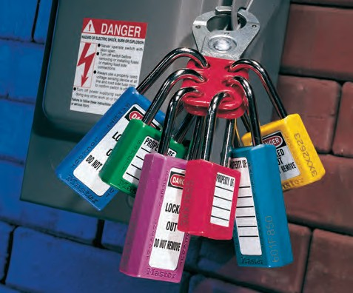 | Figure 2: Danger tags

APPENDIX D (Page 2 of 2)

TAG OUT AND LOCKOUT (ISOLATION) PROCEDURE (Continued)

Test that the isolation is effective by “trying” to reactivate the plant/equipment without exposing the tester or others to risk. Failure to reactivate the plant/equipment means that the isolation procedure is effective and that all stored energies have dissipated. This may require further measures to safely release these energies (e.g. hydraulic or pneumatic pressure, suspended weight or compressed springs).

Locks and Danger tags
Every person working on isolated equipment should fit their own lock an/or Danger tag. Alternatively, another management approved system that achieves an equivalent level of safety is to be used and included in your risk assessment.

When using locks or Danger tags, consider the following:
- Tags should be dated and signed
- Locks should be accompanied by a corresponding tag to identify who has locked out the plant/equipment
- Tags and locks should only be removed by the person who applied them or by the supervisor after consultation with the signatory of the Danger tag. In the event that the person who applied the Danger tag is unavailable, their tag or lock may only be removed in accordance with a management approved procedure. (see note below)
- Danger tags and/or locks should be fitted to all isolation points.

Note: Removing another person’s Danger tag
Under normal conditions, no person will remove or destroy another person’s Danger tag or locking device. However, at times a piece of plant/equipment is required to be returned to operation and the isolation point contains one or more Danger tags belonging to people absent from the workplace. This may occur due to workers taking a break without removing their tags or they have left the workplace to retrieve tools or other materials.
- The person requiring the plant/equipment will advise their work supervisor/person in control of the area/activity of the situation.
- The supervisor/person in control of the area/activity will contact the individual indicated on the tag and have them come back on site to remove the Danger tag/lock.
- If this is not possible, or if the person cannot be contacted, the supervisor/person in control of the area/activity will nominate a suitable proficient or competent person (in relation to task) to investigate the situation. This investigation must ensure that no person or plant/equipment will be endangered or damaged by the removal of the tag/lock by other than the signatory.
- The supervisor/person in control of the area/activity along with the nominated proficient/competent person shall co-sign the Danger tag(s), remove the locks and tags and submit them, detailing the event, to the Head of School/Branch within 24 hours of the incident occurring. The incident must be then recorded as per HSW Handbook Chapter Report a safety issue or Incident.

Out of service tags
Out-of service tags are used to identify plant/equipment/machinery that has been taken out of service due to a fault, damage or malfunction.

The out-of-service tag is to be securely fixed to the operating control power isolator with the appropriate details completed on the tag (explaining the reason for the machine being “out of service”). The out-of-service tag should not be removed until the plant/equipment is safe to be returned to service, or the reason for the out-of-service tag no longer exisits.  The out-of-service tag may be removed by:  - The person who attached it  - The supervisor responsible for the operation or repair of the equipment  - The maintenance person who carried out the repairs.  Tags can be purchased from Facilities Management Maintenance North Terrace Campus, or areas Schools/Branches can source tags from external suppliers. | Example of an “out of Service” tag