IMPLEMENTATION
Draft 2 – 21 May 2021
Aim
To prescribe the responsibilities and overarching actions required to enable worker representation and consultation on health, safety and welfare (HSW) matters which ensures the University meets the requirements of the Health, Safety and Wellbeing (HSW) Policy and the relevant sections of the Work Health and Safety Act 2012 (SA) and Work Health and Safety Regulations 2012 (SA).

 | 1 | Objectives
 |  | 1.1 | That consultation with workers occurs, involving Health and Safety Representatives (HSRs) and/or Faculty/Division HSW Committees in accordance with Part 5 of the Work Health and Safety (WHS) Act 2012 (SA).
 |  | 1.2 | That a structure exists within the University that facilitates the election of HSRs should workers decide to do so in accordance with Part 5, Division 3 of the WHS Act 2012 (SA).
 |  | 1.3 | That a pathway and procedure is identified for HSW issue resolution that allows for the rights and powers of elected HSRs.
 | 2 | Scope and application
 |  | 2.1 | This process applies to workers who are undertaking University of Adelaide related activities (including those working off campus).  Note: the WHS Act 2012 also requires consultation, co-operation and co-ordination between a person conducting a business or undertaking (PCBU) and external parties who may share HSW duties. Refer to HSW Collaboration with other organisations (including co-location) Handbook Chapter for requirements.
 | 3 | Process: HSW Consultation
 |  | Person Responsible |  |  | Actions
 |  | 3.1 | Supervisor/person in control of the area/activity (see definitions) |  | - Consult with workers they directly supervise and/or their representatives on relevant health and safety matters such as:  - when identifying hazards and assessing risks to health and safety arising from work carried out or to be carried out;  - when making decisions about ways to eliminate or minimise those risks;  - when making decisions about the adequacy of facilities they control which ensure the welfare of workers;  - when proposing changes that may affect the health or safety of workers;  - when making decisions about the local procedures for:  - monitoring the health of workers; or  - monitoring conditions in the workplace; or  - providing information and training for workers.  - Confer with the HSR elected for their area whenever reasonably requested for the purpose of ensuring the health and safety of the workers in the area.
 | 3 | Process: HSW Consultation (Continued)
 |  | Person Responsible |  |  | Actions
 |  | 3.2 | Head of Faculty/Division or nominee |  | - Maintain an HSW Committee that covers the Faculty/Division made up of Management and Staff representatives.  - Maintain a Terms of Reference (ToR) for the Committee in consultation with Committee members and advise Council Secretariat of any changes to the ToR.  - Invite elected HSRs in a Faculty or Division to be members of the Committee in accordance with the ToR.  - Conduct a process to determine staff representatives where an elected HSR declines to be a member or where no HSRs are in place.  - Allow members of HSW Committees to fulfil their role and functions as a member of the Committee.  - Provide relevant information to the Committee relating to hazards and HSW issues.  - Document agendas/papers and minutes for the Committee and make available to the workers covered by the Committee (e.g. place on the Faculty/Division website).
 |  | 3.3 | Health and Safety Representatives |  | - Represent a workgroup’s HSW issues to relevant supervisors and managers. This may include:  - discussing a HSW matter with a worker at the worksite;  - bringing a worksite HSW or welfare matter to the attention of the supervisor;  - monitoring the measures taken in relation to workers in the workgroup to comply with the WHS Act;  - investigating complaints from members of the workgroup relating to HSW issues;  - inquiring into anything that appears to be a risk to the HSW of workers in the workgroup;  - representing their workgroup’s issues to their HSW Committee or worksite consultation arrangement; and  - ensure relevant safety issues are recorded in the HSW Online Reporting System (UniSafe).
 |  | 3.4 | Committee |  | - Facilitate co-operation between management and workers on HSW matters.  - Contribute to the development and review of local HSW processes and systems.  - Meet at least once every three months and at any reasonable time at the request of at least half of the members of the committee.  Notes:  - the composition of an HSW Committee must be agreed between management and workers and should include at least 50 % worker representation not nominated by the employer and include management representation with the necessary level of decision making and expertise.  - Unless they do not wish to participate, HSRs are automatically a member of the relevant HSW Committee. If there is more than one HSR, the HSRs may agree among themselves as to who will be on the Committee. They may agree to have more than one HSR join the Committee.
 |  | 3.5 | Workers |  | - Participate in HSW consultative structures and processes.

 | 4 |  | Process: Election of HSRs
 |  |  |  | Person Responsible |  |  | Actions
 |  |  |  | 4.1 | Head of Faculty/Division  or nominee |  | - Determine, in consultation with workers, a work group or structure of work groups that covers the entire Faculty or Division. The structure of the work group or groups should:  - be sustainable, to avoid constant turnover or vacancies;  - enable easy identification by workers of:  - the workgroup to which they belong; and  - which HSR is their representative;  - be communicated to all workers in the Faculty/Division.  - Determine the number of HSRs and deputy HSRS (if any) to be elected.  Notes:  - Once agreed, work groups can be reviewed and altered at a later date upon request from workers or by the Head of Faculty/ Division after a new round of consultation has occurred. This should be considered, for example, if ongoing HSR vacancies persist.
 |  |  |  | 4.2 | Local HSW Team or  Faculty/Division nominee |  | Where the HSR position is or falls vacant, the Local HSW Team or Faculty/Division nominee must:  - Ensure nomination and election process in accordance with Appendix B.  - Advise the members of the work group of the outcome.  - Register the newly elected HSR with the SafeWork SA HSR portal.  - Update the SafeWork SA HSR portal where an HSR resigns or leaves the workgroup.  - Ensure an up-to-date list of HSRs (electronically or otherwise) is displayed for each work group by the Faculty/Division.  - Monitor where terms are ending via to SafeWork SA HSR portal and prompt nomination and election processes as required.
 | 5 |  | Process: Training and support for HSRs
 |  |  |  | Person Responsible |  |  | Actions
 |  |  |  | 5.1 | Supervisors of elected HSRs |  | - Provide any resources, facilities and assistance to an HSR for the work group that are reasonably necessary to enable them to exercise their powers or functions under the WHS Act.  - Allow a person assisting an HSR for the work group to have access to the workplace if that is necessary to enable the assistance to be provided.  - Permit an HSR for the work group to accompany a SafeWork SA inspector during an inspection of any part of the workplace where a worker in the work group works.  - Allow an HSR to spend such time as is reasonably necessary to exercise their powers or functions under the WHS Act.  - Allow, at the request of an HSR for a work group in their area, the HSR to attend a course of training that is approved by SafeWork SA and chosen by the HSR, in consultation with their supervisor (refer to SafeWork SA HSR portal).

 | 5 |  | Process: Training and support for HSRs (Continued)
 |  |  |  | Person Responsible |  |  | Actions
 |  |  |  | 5.1 | Supervisors of elected HSRs  (Continued) |  | - Release the HSR to attend their prescribed minimum training:  - as soon as practicable within a 3-month period from receiving the request; and  - with all reasonable costs of attending the course and time paid by the School/ Branch/ Faculty/ Division; and  - for the prescribed minimum number of days per year of their term:  - 5 days during their first year of term;  - 3 days during their second year of term;  - 2 days during their final year of term.  Notes:  - The prescribed minimum number of days applies to each subsequent term should an HSR re-nominate.  - Any time that an HSR spends for the purposes of exercising his or her powers or performing his or her functions including training must be with the pay that he or she would otherwise be entitled to receive for performing his or her normal duties during that period.

 | 6 |  | Process: Dispute avoidance and settlement procedure for HSRs
 |  |  |  | Person Responsible |  |  | Actions
 |  |  |  | 6.1 | HSR |  | - Follow the process outlined in Appendix A to resolve issues where they reasonably believe there is a risk to the health and safety of workers in their workgroup.  Notes:  - Advisors and/or competent persons may be included to assist the resolution process.  - Either party (the PCBU or the HSR) can at any time contact a SafeWork SA inspector for assistance on the matter.
 |  |  |  | 6.2 | Supervisor, Head of School/Branch, Head of Faculty/Division |  | In accordance with Appendix A:  - Meet or communicate with relevant parties to attempt to resolve the issue. The timeliness of response must have regard to the degree and immediacy of risk to workers.  - Provide written agreement to the issue where requested by a worker and provide a copy to all parties to the issue.  - Ensure the details are recorded in the University’s online reporting system, UniSafe as a safety issue.
 |  |  |  | 6.3 | Central HSW |  | In accordance with Appendix A:  - Review the issue and all relevant documentation relating to the HSW issue where requested by the Executive Dean/Director.  - Provide a report with recommendations to the Executive Dean/Executive Director.

 | 7 |  | Process: Issuing a Provisional Improvement Notice (PIN)
 |  |  |  | Person Responsible |  |  | Actions
 |  |  |  | 7.1 | Supervisor, Head of School/Branch, Head of Faculty/Division |  | - Display a copy of any issued PIN in a prominent place at or near the part of the workplace that is affected by the notice.  - Comply with the provisional improvement notice within the time specified in the notice, unless a SafeWork SA Inspector has been requested to review the PIN.  - Ensure the details are recorded in the HSW Online Reporting System (UniSafe) as a safety issue.  Notes: Refer to the Local HSW Team for further advice on the resolution of PINs.
 |  |  |  | 7.2 | HSR |  | - Ensure that Stage 1 of Appendix A has been attempted before issuing a Provisional Improvement Notice (PIN).  Notes:  - The HSR issuing the PIN can only do so if they have completed the approved HSR training.  - It is recommended that the HSR contact the Local HSW Team for advice and support to ensure the PIN is completed correctly and assigned to the right person of authority.  - A trained HSR may direct the cessation of work where they reasonably believe there is a serious or imminent risk to a member of their workgroup, but must first make efforts to consult with their supervisor or as soon as practicable in the event of imminent risk.

 | 8 |  | Process: Record Keeping
 |  |  |  | Person Responsible |  |  | Actions
 |  |  |  | 8.1 | Returning Officer |  | - Ensure that records of HSR nomination and election processes are maintained in accordance with the State Records of SA, General disposal Schedule No 30 issued under the State Records Act 1997.  Note: Contact the University’s Records Management Office for further assistance/information if required.

 |  | 8.2 | Head of Faculty/Division  or nominee |  | - Ensure that records of work group formation and HSW Committee minutes and agenda papers and other consultation records are maintained in accordance with the State Records of SA, General disposal Schedule No 30 issued under the State Records Act 1997.  Note: Contact the University’s Records Management Office for further assistance/information if required.

 | 8 |  | Process: Record Keeping (Continued)
 |  |  |  | Person Responsible |  |  | Actions
 |  |  |  | 8.3 | Supervisor/person in control of the area/activity |  | - Ensure that consultation records are maintained in accordance with the State Records of SA, General disposal Schedule No 30 issued under the State Records Act 1997.  - These records may be in the form of:  - File notes of discussions on safety matters;  - Emails;  - Names of persons on HSW risk assessments, workplace inspections, hazard identification checklists;  - Minutes of meetings.  Note: Contact the University’s Records Management Office for further assistance/information if required.

 | 9 | Definitions  Health and Safety Representative – is a person who has been elected by a workgroup to represent them to management on HSW issues. They act in a voluntary capacity representing their workgroup, and have specific roles and functions under the WHS Act and HSW Regulations which may be utilised where there are safety concerns, e.g. to issue a ‘Provisional Improvement Notice’ or direction that work cease.  Consultation – under the WHS 2012 means the sharing of relevant information about HSW matters and giving workers reasonable opportunity to :  - express their views and raise HSW issues,  - contribute to the decision-making process in relation to a matter,  - having their views taken into account, and  - being advised of the outcome of the consultation  and may be conducted informally during the conduct of HSW activities such as walk through inspections or observations, through regular team meetings or may be conducted formally through HSRs or HSW Committees.  PIN (Provisional Improvement Notice) – a written notice (refer SafeWork SA PIN form) issued by a trained HSR to a person to remedy a contravention or prevent a contravention of the WHS Act.  Supervisor - In the context of this chapter the supervisor has two meanings:  - The line manager of a staff member or the principle supervisor of a higher degree research student, except where the worker’s activity is supervised by someone as described in the second meaning below.  - Any other individual who (separate to the line manager/principle supervisor) has control of a laboratory, clinic, workshop, field activity or other activity in which the worker is participating or working. For example a workshop manager who has control of what is undertaken and/or who determines which workers may/may not work within the workshop they control. (Note: Control means that these individuals have the right to deny access to or stop any activity until they are satisfied that the activity can occur safely.)  Worker – means according to the WHS Act 2012 (SA) a person where the person carries out work in any capacity for a person conducting a business or undertaking, including work as -  (a) an employee; or  (b) a contractor or subcontractor; or  (c) an employee of a contractor or subcontractor; or  (d) an employee of a labour hire company who has been assigned to work in the person's business or undertaking; or  (e) an outworker; or  (f) an apprentice or trainee; or  (g) a student gaining work experience; or  (h) a volunteer; or  (i) a person of a prescribed class.  The person conducting the business or undertaking is also a worker if the person is an individual who carries out work in that business or undertaking. Note: Higher Degree Research and Honours students and Academic Visitors are likely to be workers under the WHS Act 2012 (SA).
 | 10 | Performance Measures  The HSW Team will use the performance measures listed below to assist in identifying areas of success and/or where corrective action is required to meet the objectives and targets of this process.  The level of compliance with the chapter and effectiveness will be determined during the internal audit process.
 | 11 | Useful information and resources
 |  | 6.1 | University related documents  HSW Handbook Chapter HSW Collaboration with other organisations (including co-location) Handbook Chapter
 |  | 6.2 | Related Legislation  Work Health and Safety Act 2012 (SA)  Work Health and Safety Regulations 2012 (SA)  Code of Practice HSW Consultation, Cooperation and Coordination 2020
 |  | 6.3 | Useful Web-links  SafeWork SA  SafeWork Australia

APPENDIX A

Dispute avoidance and settlement procedure for Health & Safety Representatives (HSRs)

Note: An elected and trained HSR may exercise their powers in accordance with the WHS Act at any time (including contacting SafeWork SA to seek advice and guidance on the matter, issue a Provisional Improvement Notice (PIN) or direct the cessation of unsafe work), however where the exercising of that power requires them to consult, HSRs should attempt Stage 1 of this process.

Stage 1
Safety issues of concern identified by the HSR should be raised with the relevant supervisor/manager for consideration and response.

Note:
- The issue must be reported in the HSW Online Reporting System (UniSafe) by a worker or the HSR
- Once reported in UniSafe, local HSWO’s investigate and provide advice and recommendations to the relevant supervisor/manager to eliminate or minimise the risk from the identified hazard/s.

Should the actions taken by the supervisor/manager not resolve the safety issue and the HSR reasonably believes a risk to health and safety still exists, move to Stage 2.

MATTER RESOLVED

Safety issue/s, not resolved by Stage 2, should be raised by the HSR to the Executive Dean/Director for final resolution.

Note:
- Where requested by the Executive Dean/Director, the issue and all relevant documentation relating to the HSW issue raised will be reviewed by the HSW Central team and a report with recommendations provided for the Executive Dean/Executive Director to consider.

The Executive Dean/Executive Director will advise the HSR of their decisions and any subsequent actions in writing.

Stage 3
Safety issue/s, not resolved by Stage 1, should be raised by the HSR to the relevant Head of School or Branch for consideration and response.

Note:
- Additional advice may be sought from competent external persons
- Either party may be assisted or represented by a person nominated by that party
- Either party may make a request to SafeWork SA for advice
- If the Head of School/Area was the supervisor that considered the HSW matter under Stage 1, then move to Stage 3.

Should the actions taken by the Head of School/Branch not resolve the safety issue and the HSR reasonably believes a risk to health and safety still exists, move to Stage 3.

Stage 2
APPENDIX B (page 1 of 1)

Process to support the nomination and election of HSRs

Nomination process - Local HSW Team or Faculty/Division nominee
- Determine a list of eligible members of the work group.
- Determine in consultation with relevant workers, who will be the Returning Officer.
- Email Web & Digital, Marketing & Recruitment at web.requests@adelaide.edu.au
  - quote reference https://www.adelaide.edu.au/hr/hsw/hsw-staff-intranet/health-safety-representative-nomination-form asking they upload the nomination form to the Faculty intranet
  - provide the name of the designated workgroup
  - provide the name of the Returning Officer
  - provide the nomination due date (allow a two week timeframe).
- Notify the designated workgroup of the nomination process. Refer to <sample email #1 on Community of Practice portal>.
- The Returning Officer cannot be a candidate in the election but may be from outside the workgroup.

Receiving Nominations - Responsible Officer
- The Responsible Officer will receive the nominations via the on-line form.
- Nominees must be a member of the work group.
- Where no nomination is received the position will be vacant until a worker nominates.
- If the position remains vacant for more than three (3) months and a nomination is then received, the Local HSW Team must advise the work group and provide a fresh opportunity for workers to nominate.
- Where the number of nominations equals the number of vacancies, the nominee(s) are taken to be elected to the work group.
- Where more nominations than vacancies are received, an election process is required.
- Responsible Officer to advise the Local HSW Team or Faculty/Division nominee of the outcome.
- Responsible Officer to retain records of the process (emails etc) in accordance with the State Records Act 1997.

Advising of appointment of HSR where no election is required - Local HSW Team or Faculty/Division nominee
- Advise successful HSRs of the result. Refer to <sample email # 2 on Community of Practice portal>.
- Advise workgroup of the result. Refer to <sample email # 5 on Community of Practice portal>.
- Retain records of the process (emails etc) in accordance with the State Records Act 1997.

Conduct of election process if required - Local HSW Team or Faculty/Division nominee
- Email Web & Digital, Marketing & Recruitment at web.requests@adelaide.edu.au
  - quote reference https://www.adelaide.edu.au/hr/hsw/hsw-staff-intranet/health-safety-representative-ballot-form asking they upload the ballot form to the Faculty intranet
  - provide the name of the designated workgroup
  - provide the list of HSR nominees
  - provide the name of the Returning Officer
  - provide the voting due date (allow a two week timeframe for voting)
- Notify the designated workgroup of the voting process. Refer to <sample email #3 on Community of Practice portal>.
- All members of the work group must be given the opportunity to vote in the election.

Receiving Votes - Responsible Officer
- The Responsible Officer will receive the votes via the on-line form.
- The successful candidate is that with the most votes for one vacancy or nominees will be ranked by the most votes and appointed to the vacancies in order of rank.
- Where the election results in a tie, the two nominees will be decided by the toss of a coin.
- Responsible Officer to advise the Local HSW Team or Faculty/Division nominee of the outcome.
- Responsible Officer to retain records of the process (emails etc) in accordance with the State Records Act 1997.

Post election - Local HSW Team or Faculty/Division nominee
- Advise successful HSRs of the election result. Refer to <sample email # 4 on Community of Practice portal>.
- Advise workgroup of the election result. Refer to <sample email # 5 on Community of Practice portal>.
- Register the newly elected HSR with the SafeWork SA HSR portal.
- SafeWork SA will email the HSR their portal registration details and instructions on the process to access training.
- Update the SafeWork SA HSR portal (log in details to be provided to HSW Hub) where an HSR resigns or leaves the workgroup.
- Ensure an up-to-date list of HSRs (electronically or otherwise) is displayed for each work group by the Faculty/Division.
- Monitor where terms are ending and schedule nomination and election processes as required.
- Retain records of the process (emails etc) in accordance with the State Records Act 1997.
To be hosted on Community of Practice Portal

On line nomination and ballot forms

Designed by Web & Digital, Marketing & Recruitment at web.requests@adelaide.edu.au
Quote reference https://www.adelaide.edu.au/hr/hsw/hsw-staff-intranet/health-safety-representative-nomination-form

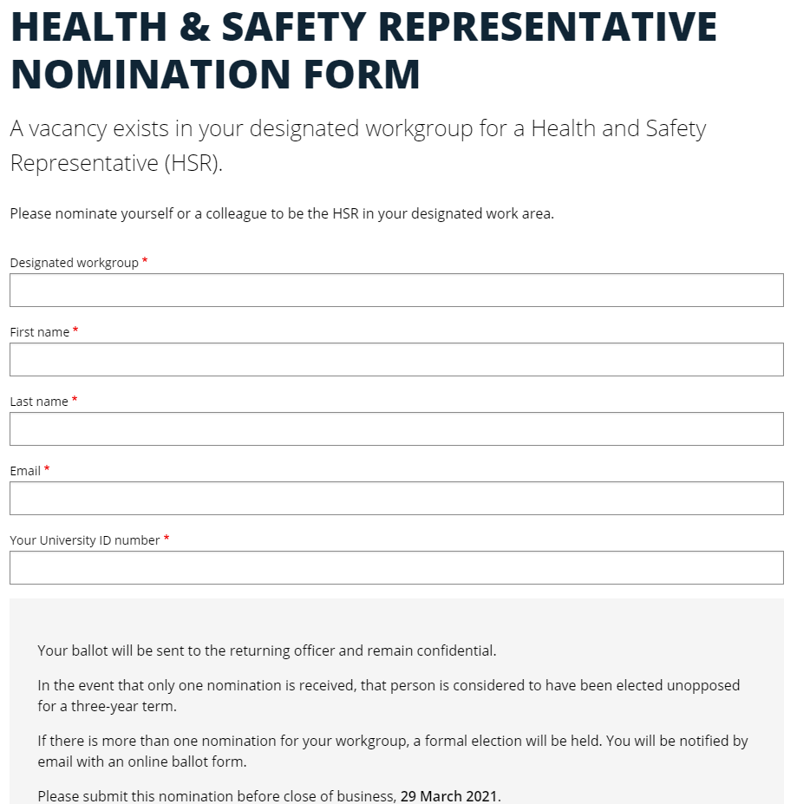
Provide due date

Quote reference https://www.adelaide.edu.au/hr/hsw/hsw-staff-intranet/health-safety-representative-ballot-form

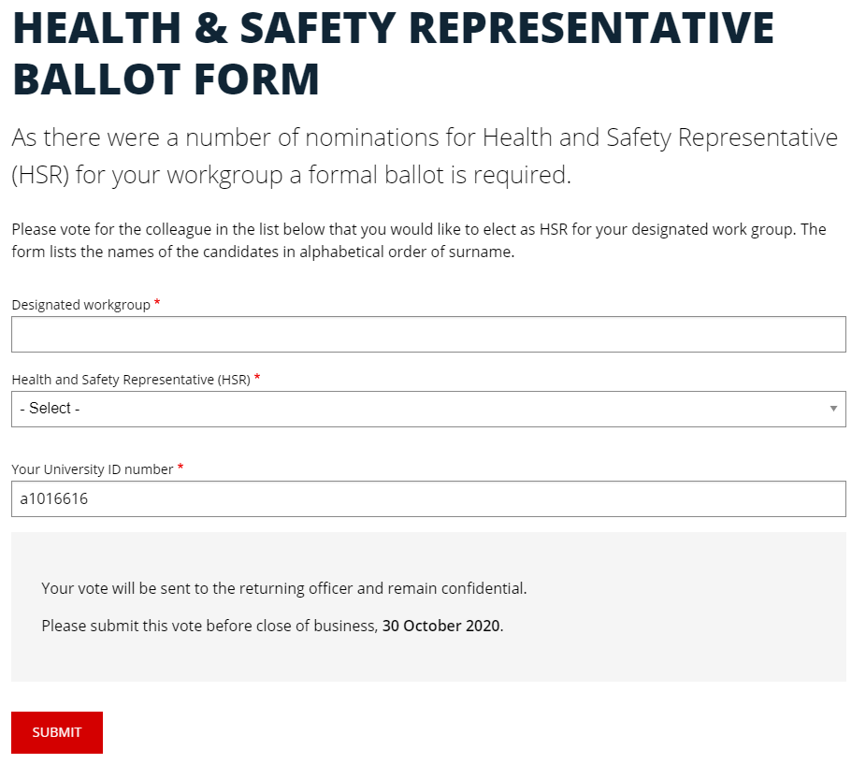
Provide due date

To be hosted on Community of Practice Portal

Sample emails supporting HSR nomination and election process

Email # 1 – Advising designated workgroup of the nomination process

Dear insert Faculty/School/Branch,

I wish to advise of a call for nominations for insert number Health and Safety Representative(s) of insert name of designated workgroup. Information on the role of an HSR can be found on the University of Adelaide HSR Portal.

Should you be interested in nominating as an HSR, please submit your nomination using the confidential online nomination form insert web address of online nomination form. Your nomination will be received by the returning officer insert name.

Regards,
<insert contact details>

Email # 2 – Advising HSR(s) where no election required

Dear HSR name,

Thank you for your nomination for Health and Safety Representative (HSR) for the insert name of designated workgroup.

As the number of nominations equalled the number of HSR vacancies, it is considered that you have been elected for a three year term. Information on the role of an HSR including your entitlement to HSR training, can be found on the University of Adelaide HSR Portal.

As you are the successful candidate it is a requirement that I add you to the SafeWorkSA HSR Portal. Could you please fill in the table below and send back to me to enable this to occur. SafeWork SA will email your portal registration details and instructions on the process to access HSR training. Notification to the workgroup will be sent in a separate email

Title:
Given Name(s):
Surname:
Date of Birth:
Email:
Mobile No.:
Site/Location:
Workgroup:
Position:

Regards,
<insert contact details>

Email # 3 – Advising of election process

Dear insert Faculty/School/Branch,

I wish to advise that there are insert number nominations for Health and Safety Representative (HSR) of insert name of designated workgroup and a formal ballot is required. Information on the role of an HSR can be found on the University of Adelaide HSR Portal.

Please submit your ballot using the confidential online ballot form insert web address of online ballot form. The form lists the names of the candidates. Your ballot will be processed by the returning officer insert name.

Regards,
<insert contact details>

Email # 4 – Advising of HSRs of election result

Dear HSR name,

Thank you for nominating for the position of HSR. You have been elected as HSR for the designated workgroup for a three year term. Information on the role of an HSR including your entitlement to HSR training, can be found on the University of Adelaide HSR Portal.

As you are a successful candidate it is a requirement that I add you to the SafeWorkSA HSR Portal. Could you please fill in the table below and send back to me to enable this to occur. SafeWork SA will email your portal registration details and instructions on the process to access training. Notification to the workgroup will be sent in a separate email.

Title:
Given Name(s):
Surname:
Date of Birth:
Email:
Mobile No.:
Site/Location:
Workgroup:
Position:

Regards,
<insert contact details>

Email # 5 – Advising workgroup of result

Dear insert Faculty/School/Branch,

I advise that the following have been elected as HSR for the designated workgroup for a three year term.

INSERT name(s)

Information on the role of an HSR can be found on the University of Adelaide HSR Portal.

Thank you to all those who nominated as HSR and participated in the process.

Regards,
<insert contact details>

