EVENTS SAFETY MANAGEMENT:  COVID Guiding principles for running an event in 2022 | APPENDIX E

D Guiding principles for running an ev

The University is exempt from the Emergency Management Activities - General Direction when conducting activities that are necessary for its normal business and when doing so, is not required to have a COVID Management Plan, COVID Safe Plans, QR Codes or COVID Marshalls.
For events that are not necessary for our normal business (including teaching or research activities) and that bring together numbers of people that exceed restrictions imposed for gatherings and/or activities, the University is subject to the same restrictions and requirements as other businesses and organisations. If you are planning such an event, you must check the Current Activity Restrictions and ensure all requirements are adhered to.

As borders open-up and the number of COVID-19 cases starts to increase, the South Australian community and the University will face challenges and concerns around holding public events.

These principles have been developed as a quick reference to help you understand, outside of government restrictions, some general operational arrangements that event organisers should take. For further advice please contact Senior HSW Advisors, details here.

Principles for Event organisers and coordinators
- The risk of exposure to/community transmission of COVID-19 at public events will be a significant hazard as we move forward. For this reason, the University should encourage only those people who are fully vaccinated to attend our public events.

All persons should be informed that they are not to attend if they are experiencing any COVID or flu like symptoms and that indoor mask requirements, physical distancing and density requirements apply.

While event organisers may not need to verify vaccination status, they will need to comply with the basic COVID safe requirements including physical distancing, mask wearing and hygiene.

- Each event involving the public (defined here), must have its own COVID Safe Plan and QR Code if more than 100 people are attending. When completing the required online form do not use generic terms to identify the business such as “University of Adelaide”. Use the name of your event, followed by the identifier “UoA”. See the example below.

Event organisers need to make sure they remove QR code posters at the end of the event.

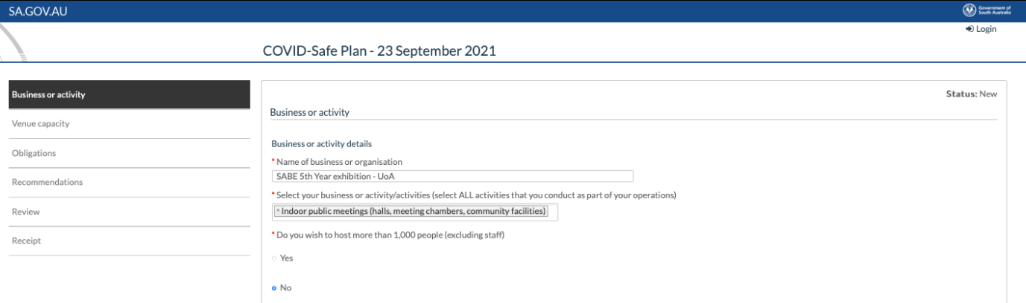
- Event organisers should ensure people attending indoor public events wear masks. SA Health provides a range of posters that could be used for events to inform those attending of the requirement (see here). Provisions should be made to provide attendees with a mask if they arrive without one.
- Additional restrictions apply to high-risk activities, such as those involving dancing and singing or food and beverage consumption. If food and beverages are going to be provided at the event, it should be carried out by contracted caterers in line with their own COVID safety management plan.
- When planning an event, event organisers should ensure that seating arrangements allow for physical distancing and density requirements to be met, and that hand sanitisers are available.

