COMPUTER WORKSTATION ERGONOMIC SELF-ASSESSMENT

Name |  | Date Assessed
Reason for conducting self-assessment | - New Starter | - Injury/Discomfort
 | - Relocation | - New Equipment
 | - Remote work location / Work from home | - Other – please detail below:

If you have an injury or medical condition that requires specialist assessment,
please contact the HSW Team via email: hswteam@adelaide.edu.au

Summary of Recommended / Identified Actions to discuss with your supervisor
(that could not be corrected / implemented at time of self-assessment )
Item  (e.g. chair, desk, monitor) | Action Required | Decision after discussion with supervisor

Before starting, consider the positioning shown in the diagram below for a seated computer workstation
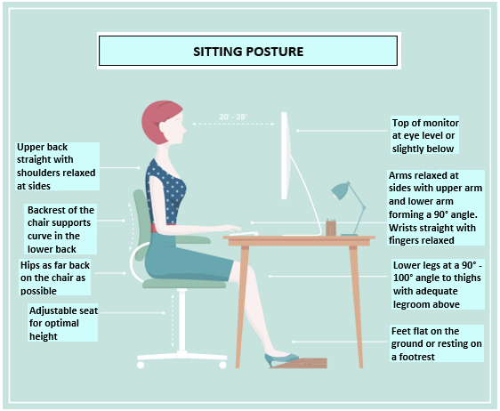

CHAIR | Yes | No | N/A | Comments / Actions | Corrected at time of assessment
Chair swivels freely to allow me to face my non-computer tasks instead of twisting in my seat
Chair is stable
Chair has a cushioned rounded front edge
Chair has adjustable height and backrest for lumbar support
Seat Pan
When seated in the chair, with back fully supported by back-rest, there are two to three finger spaces between the back of the knees and the edge of the seat
Pan of seat is level or not tilted upwards
Back Rest
Back rest (lumbar support) is adjusted so that it supports the lower back when sitting upright
Arm Rests
If arm rests are present they are adjusted to ensure that movement of chair is not impeded (ie can fit under desk)
Chair Height
Chair height is adjusted so that user can sit with elbows at approximately 90˚with adequate forearm clearance above the desk surface
Thighs are parallel to the floor with feet flat on the floor or supported on a footrest

DESK | Yes | No | N/A | Comments / Actions | Corrected at time of assessment
When seated the user can comfortably reach all equipment and papers they need to use frequently
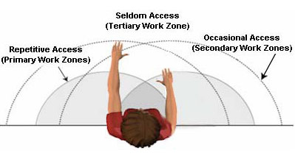
There is sufficient leg room
The area under the desk is clear so that stored items do not encroach on space, impede movement or compromise posture
Desk height is suitable for individual (if desk height cannot be adjusted, adjust chair height and make use of footrest if required). Note that in some circumstances it may be necessary to investigate options for increasing the desk height

Height Adjustable Workstations
Use of height adjustable workstations can help to encourage postural variation and, in some cases, may be required or encouraged to help in the management of injury or medical conditions. When using a height adjustable workstation, the following should be considered:
- Setting standing desk height to allow operation of keyboard and mouse with elbows at ninety degrees and shoulders relaxed
- Use of an anti-fatigue mat to reduce tiredness and leg / back soreness that may be associated with standing more than 2 hours per day.
- Alternating between a sitting and standing posture frequently throughout the day.
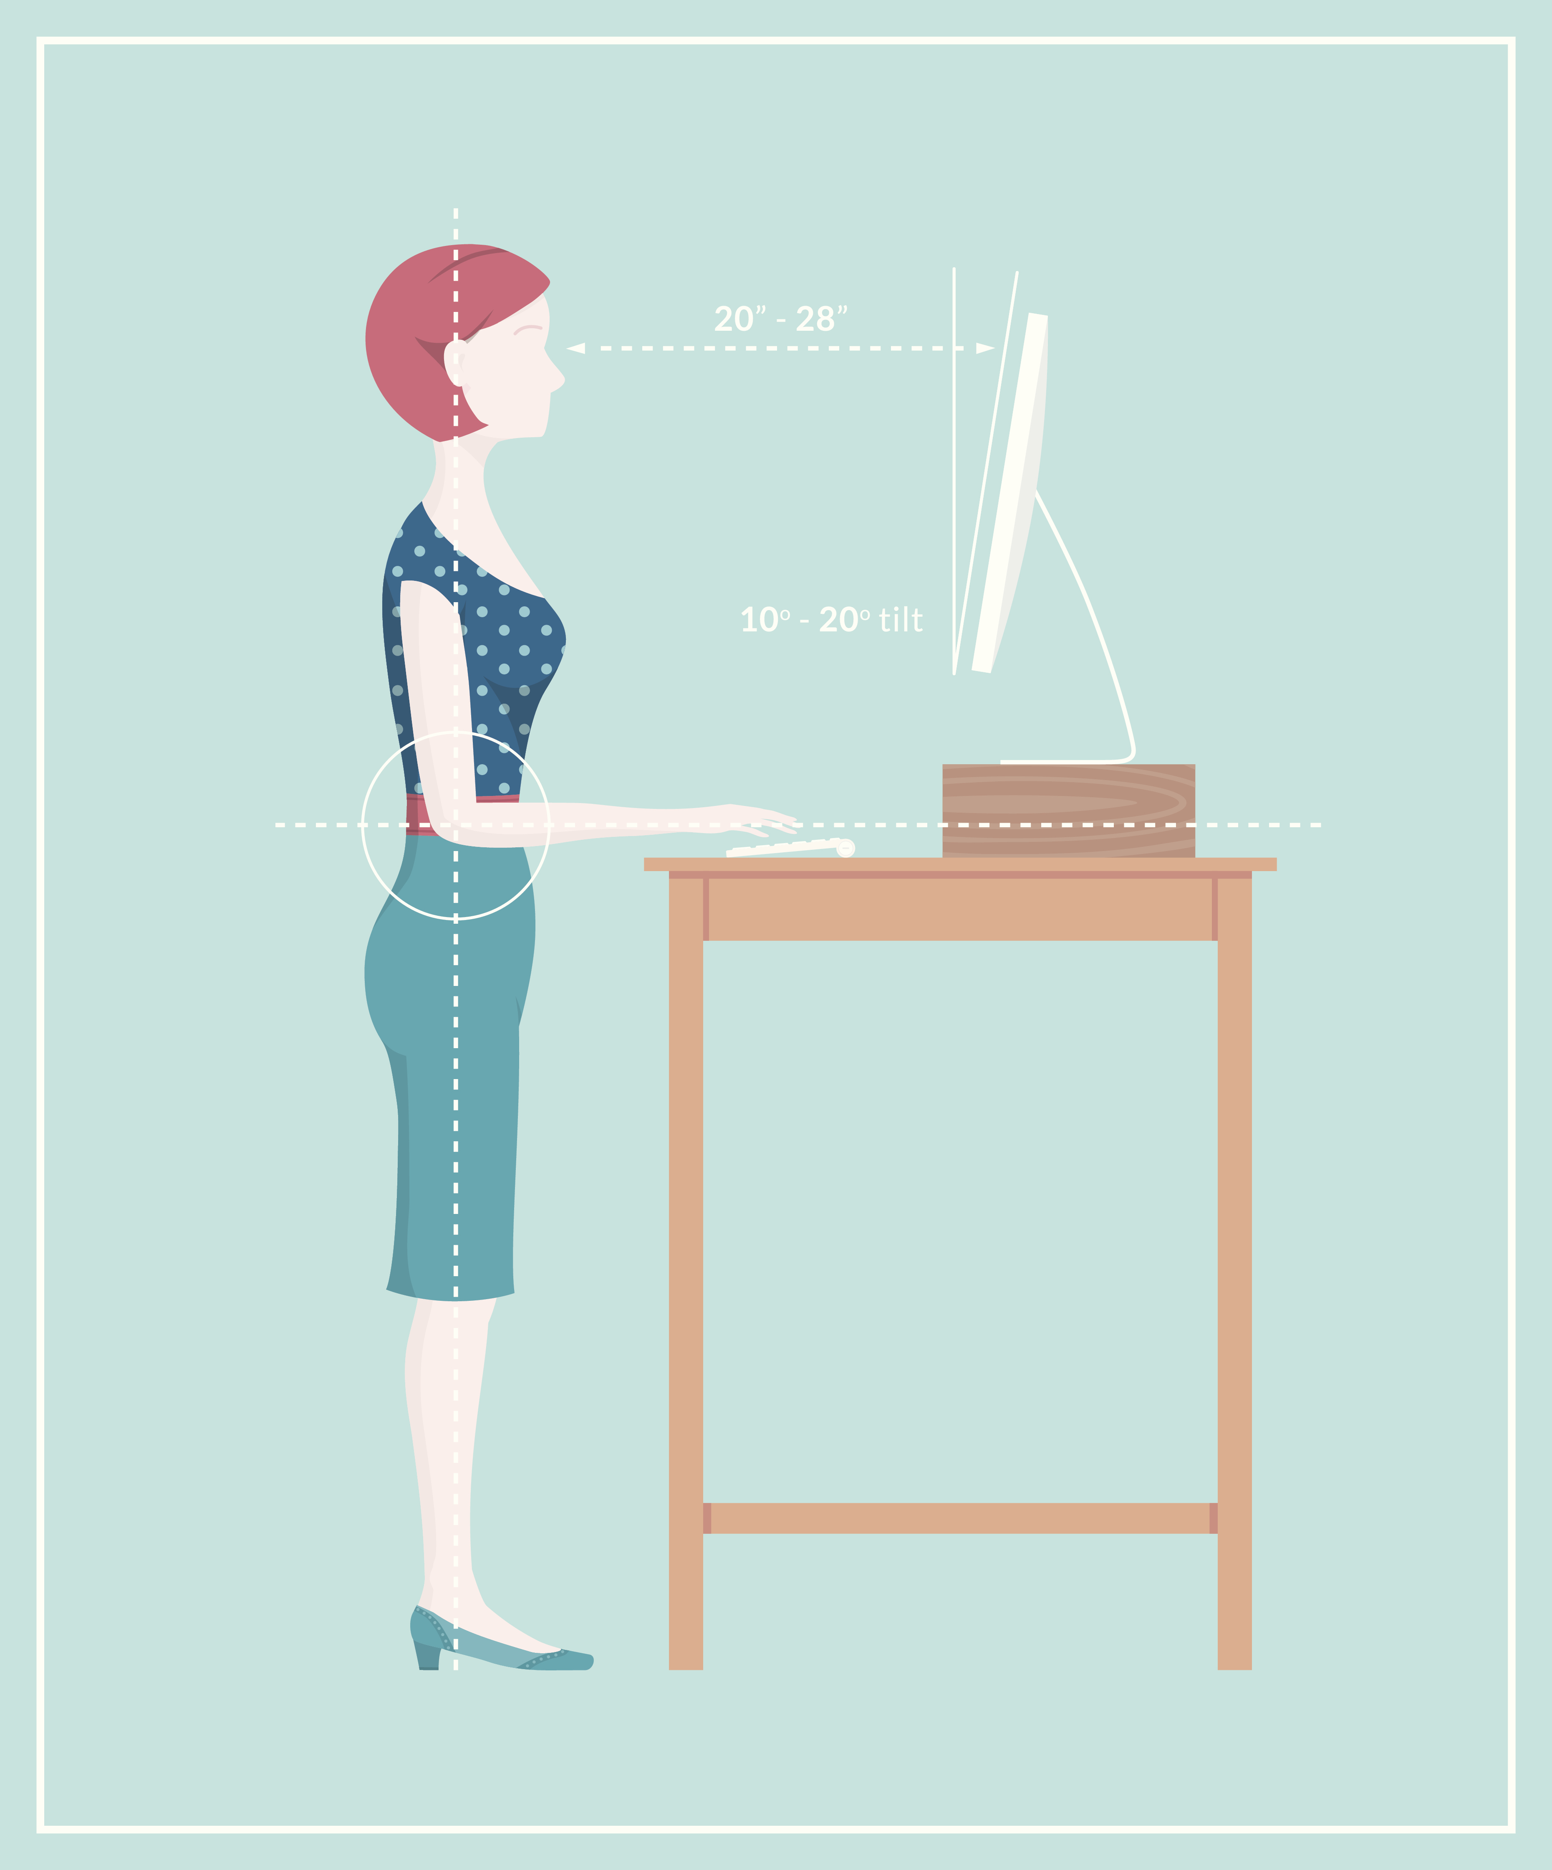

MONITOR | Yes | No | N/A | Comments / Actions | Corrected at time of assessment
Use of multiple monitors – Where possible, designate one monitor as your primary screen. This primary screen is the one you use the most. The primary screen should be centrally aligned with your keyboard, mouse and chair. The other monitor is your secondary monitor and should be used for reference. This monitor should be placed directly beside the primary monitor at the same height. When two monitors are used equally, they should be centrally aligned and adjusted to the same height and distance.
The main screen is directly in front and approximately one arms length away from user to minimise stretching / craning of neck and twisting (note – make adjustments for users with glasses e.g. bifocals usually require the screen to be lower and/or two screens)
The height of the monitor should be set so that the top of the screen is just below eye level. If the monitor does not have sufficient height adjustability, a monitor stand or riser may be required (make adjustments for users with multi-focal lenses)
Screen is free from glare and reflections from light sources (try to place monitors to the side of the light source, not directly underneath)
During intensive periods of screen time take short breaks look away from the computer screen every 20 to 30 minutes

KEYBOARD |  | Yes | No | N/A | Comments / Actions | Corrected at time of assessment
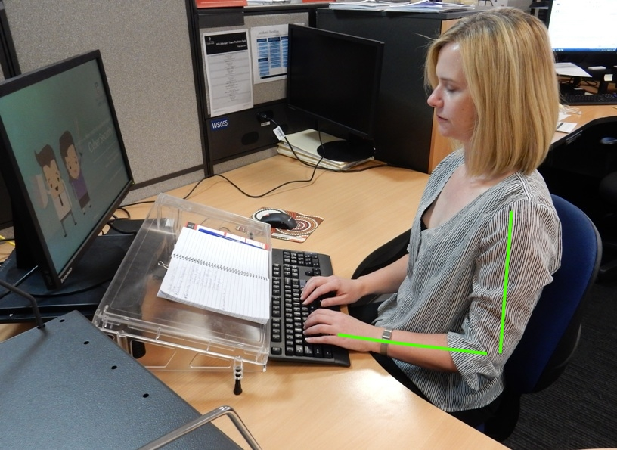

Keyboard is positioned close enough to allow elbows to remain under shoulders (at 90˚) and close to body (approximately 6cm from edge of desk) – see above
Wrists are maintained in a straight “neutral” position (see above)
Keyboard is positioned so that alpha keys are directly in front of user (note that position should be adjusted for use of numeric keypad if necessary)
Feet of keyboard are retracted to ensure neutral wrist position when typing
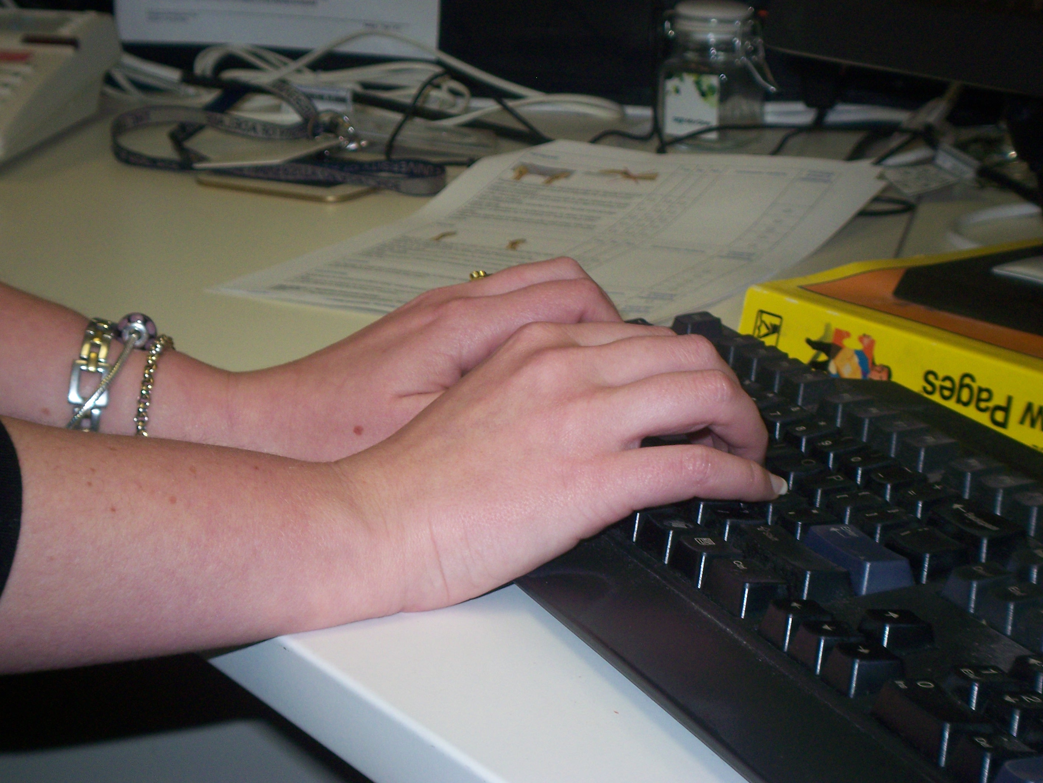  X | Wrists are elevated in a neutral position to allow natural extension of forearm (ie not resting on desk surface when typing)
Drop-down keyboard surfaces are only used when they have sufficient surface area to allow positioning of mouse on same surface

MOUSE |  | Yes | No | N/A | Comments / Actions | Corrected at time of assessment
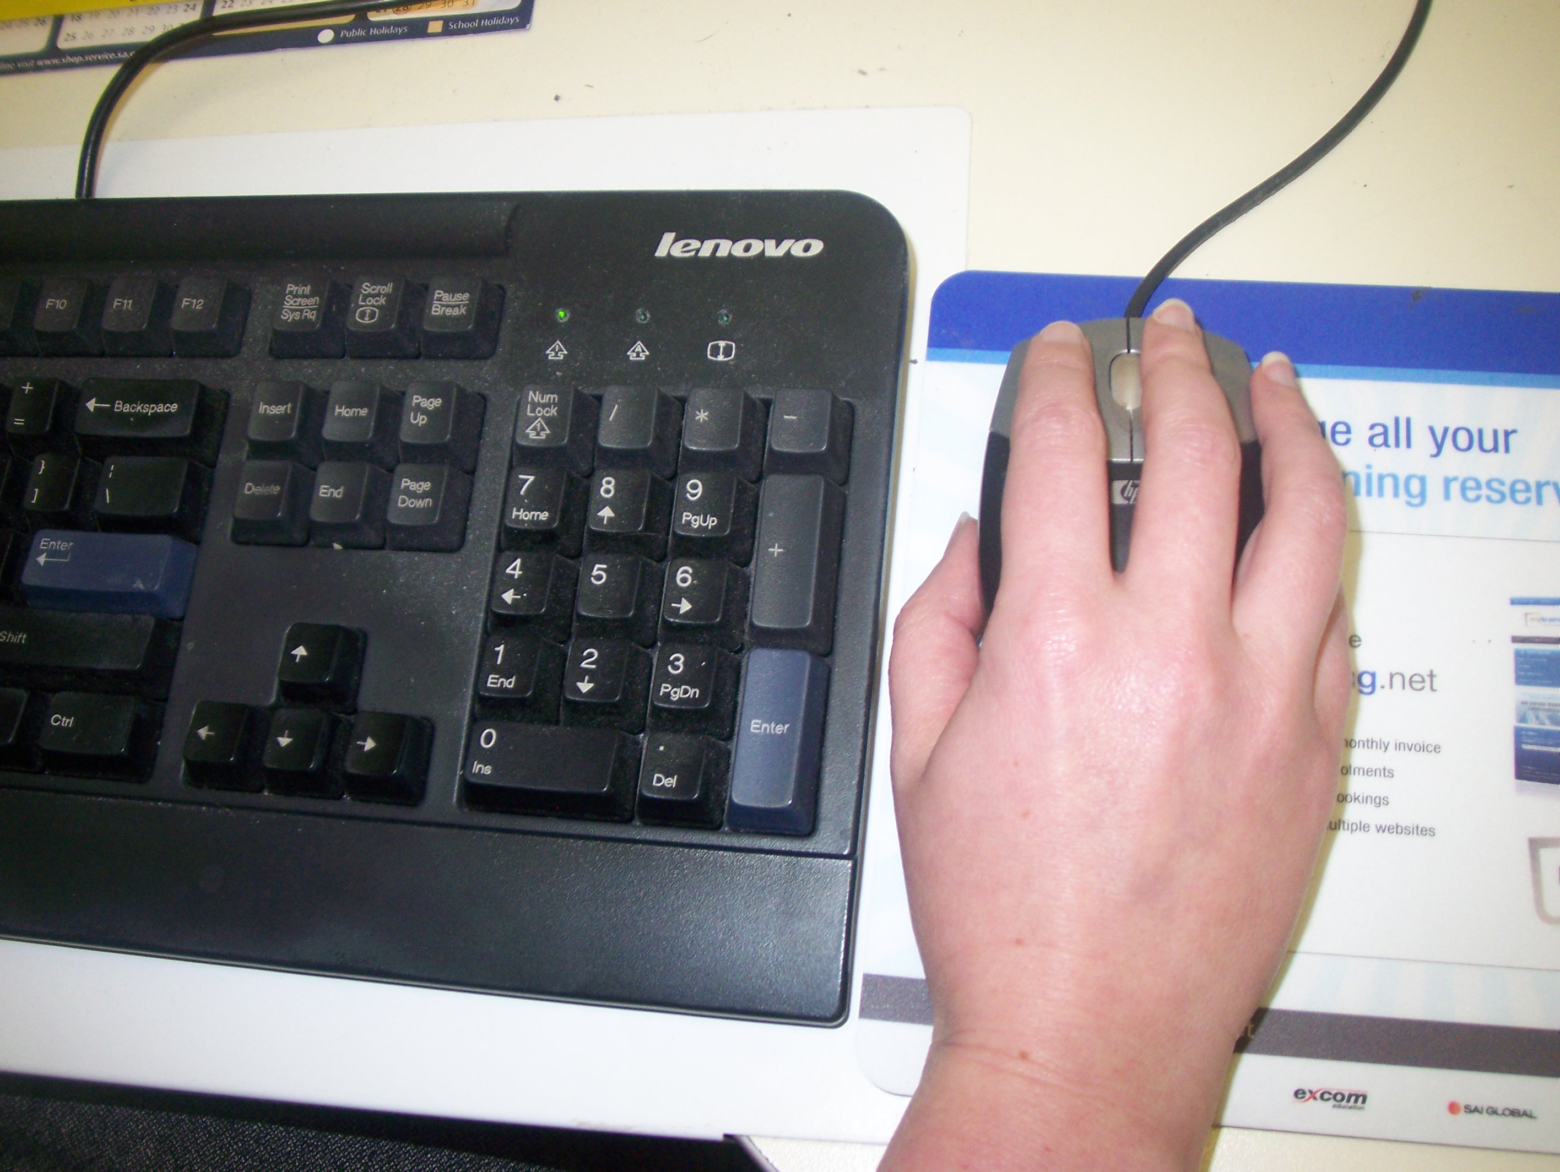 | Mouse is positioned close to user, next to keyboard and on same level, to allow elbows to remain under shoulders (at 90˚) and close to body
Mouse is of suitable size for user (ie not using small lap-top style mouse for ongoing use)
Mouse is operated using the larger muscles of the arm and the shoulder as the pivot point, rather than the wrist

LAPTOPS | Yes | No | N/A | Comments / Actions | Corrected at time of assessment
If a laptop is used for prolonged periods, a docking station and external keyboard and mouse are used
Options for transporting laptop are considered (eg trolley case, backpack)

TELEPHONE | Yes | No | N/A | Comments / Actions | Corrected at time of assessment
Telephone is positioned within easy reach and on non-dominant side
A head-set is available for prolonged and frequent telephone use during simultaneous keying/writing

DOCUMENT HOLDER | Yes | No | N/A | Comments / Actions | Corrected at time of assessment
A document holder is available if frequent transcribing from hard copy to computer is required
The document holder is positioned between monitor and keyboard or adjacent and at same height to screen

ENVIRONMENTAL | Yes | No | N/A | Comments / Actions | Corrected at time of assessment
Glare control measures are implemented if required (eg. Overhead lighting is diffused, monitor is repositioned, use of anti glare screen)
The lighting is suitable (eg not too bright, or too dim – consider the type of tasks performed)

FURTHER INFORMATION
- Long periods of sitting can reduce the health benefits of being physically active (Australian Government, Physical activity and exercise guidelines for all Australians). Try reducing your sitting time by:
  - Alternating your position every 20 to 30 minutes by incorporating whole-of-body movement (ie standing out of your chair).
  - Take the stairs instead of the lift (if physically able)
  - Periodically visit colleagues face to face, rather than contacting them via phone or email
  - Leave your desk during your breaks and enjoy a short walk (if physically able)

- Utilise breaks to minimise your screen time

- Remember, its important to be mindful of the same ergonomic principles when considering your computer set-up / screen time at home.

NOTES

Further Information
If you require further information, please contact the HSW team at: hswteam@adelaide.edu.au

