HAZARD MANAGEMENT – EVENT SAFETY MANAGEMENT PLAN (RISK ASSESSMENT) | Appendix B (Page 1 of 2)

Stage 2 and Stage 3 – Risk Assessment and Control

List the potential hazards/issues  identified in the Hazard Identification Process from Appendix A.  and  When and where the hazard  is present (i.e. when is a person at risk of exposure to the hazard) | Inherent risk  assessment  rating  Before controls are implemented  (Refer to the risk assessment Tables –  Appendix B page 2)  L, M, H, VH | List the control measures implemented (i.e. in place)  - Control measures are to be in accordance with the Hierarchy of Control. Refer to Appendix C for examples.  - Choose the control(s) that most effectively eliminate the hazard or minimises the risk.  - Record the control measures in place under the relevant control measure  (e.g. list in order under the following headings - substitution, isolation, engineering, administrative, Personal Protective Equipment).  - Ensure that control measures do not introduce new hazards. | Residual risk  rating  After controls in place  The highest rating is to be transferred to the  top of Appendix A.
Planning
Unforeseen circumstances, concurrent events. |  | Event Plan (including but not restricted to):  - Risk Assessment.  - Timetable.  - Timeframe. (Start and finish times)  - Contingency planning. (E.g. Severe weather, occupancy limit exceeded, )  - Event contact list including: Event organisers, University coordinator, security, emergency, contractors etc.  - Worker/volunteer pre-screening: training and induction, police clearance requirements.
Venue unavailable or in competition with contiguous event. |  | Book venue. (Including bump in/out)
Denied access to premier location. |  | VC Permission (if location requires it)
Inadequate facilities – ancillaries. |  | Ancillaries booked: E.g. AV, power, additional cleaning, tables & chairs.
Inadequate facilities – amenities. |  | Amenities booked: Drinking water, toilets, rubbish bins etc.
Penalty for unauthorised activity. |  | Permits:  - Infrastructure Permit System. E.g. General permission, Hot Work, confined space etc. (Refer below)  - Parking.  - Liquor licencing.
Loss of control – patrons/public. |  | Security requirements:  - Number of security personnel required.  - Competence & Registration of security personnel.  - Barrier/fence access requirements.
Loss of control – emergency. |  | Emergency management plan  - Marshalls.  - Alarms.  - Assembly points.  - First aid requirements.  - Firefighting equipment.  - Communication methods. (E.g. 2 way radios / mobile phones / bullhorns etc.)
Financial Risk |  | Insurance requirements.
Vehicular damage to personnel, plant, environment or infrastructure. |  | Traffic Management Plan (includes but not restricted to):  - Access restrictions (Gates, machine clearance, prohibit driving on lawns etc.)  - Defined non-trafficable areas. E.g. Lawns, pavers etc.  - Speed limits.  - Lay down areas.  - Time frames.  - Pedestrian access.  - Disability access.  - Emergency vehicle access.  - Signage.  - Spotters used with mobile plant.  - Parking attendants.
Event exceeding reasonable behaviour. |  | Event procedures & rules:  - Behaviour. E.g. follow reasonable instructions, language, fighting, weapons etc.  - Dress code.  - Noise.  - Rubbish.  - Lawns.  - No smoking.  - Drugs.  - Alcohol.  - Fire & cooking.  - Lost children.
Inadequate power, electric shock, fire. |  | Power:  - Circuit capable of meeting demand.  - Connection by licenced electrician.  - Testing/tagging.  - No daisy chaining of extension cords and/or distribution outlets.  - Cables to be protected from traffic and not provide trip hazards.  - Cables terminations rated to at least IP54.
Working outside University requirements. |  | Incident management and reporting.  Permit/Permission  - High risk work:  - SWMS  - Licences  - Plant registration.  - Inspection/maintenance records.  - Sign in/out.
Contractor Management
Inadequate personnel. |  | Identify Contractors and Sub-contractors. (Event and bump in/out)
Contractors denied access to site. |  | Verification of Inductions, licences and competency.
High risk work |  | No high risk work without a permit.
Bump in / Bump Out
Loss of control |  | All of the above and …
Public injured |  | Restrict public access during bump in/out.
Working outside agreed parameters. |  | Conformance with all agreed permits and plans.
Event
Workers/volunteers inadequate knowledge. |  | All workers/volunteers attend site pre-start / toolbox meeting.
Loss of control – patrons and public. |  | Entrance to event requirements (E.g. by invitation or ticket.)
Loss of control – outside event plan. |  | Monitor key indicators. (E.g. number of patrons, temperature, noise etc.)  Enact contingency plan if parameters exceeded.
Running overtime. |  | Patrons clearly advised of event start and finish times.

Staff related activities (Note – Low and Medium Residual Risk does not require Manager/Supervisor authorisation) |  |  | Student related activities
Author | Name and  Signature |  | Author | Name and  Signature
High Residual Risk –  Authorised by Manager/Supervisor | Name and  Signature/authority |  | Low and Medium Residual Risk –  Authorised by Manager/Supervisor | Name and  Signature/authority
High Residual Risk –  Authorised by Head of School/Branch | Name and  Signature/authority |  | High Residual Risk –  Authorised by Head of School/Branch | Name and  Signature/authority
Very High Residual Risk –  Authorised by VC&P | Name and  Signature/authority |  | Very High Residual Risk –  Authorised by VC&P | Name and  Signature/authority

HSW Handbook | Events Safety Management (Information Sheet) | Effective Date: | 28 January 2016 | Version 1.0
Authorised by | Associate Director, HR Compliance and Improvement Services | Review Date: | 28 January 2019 | Page 6 of 15
Warning | This process is uncontrolled when printed. The current version of this document is available on the HSW Website.

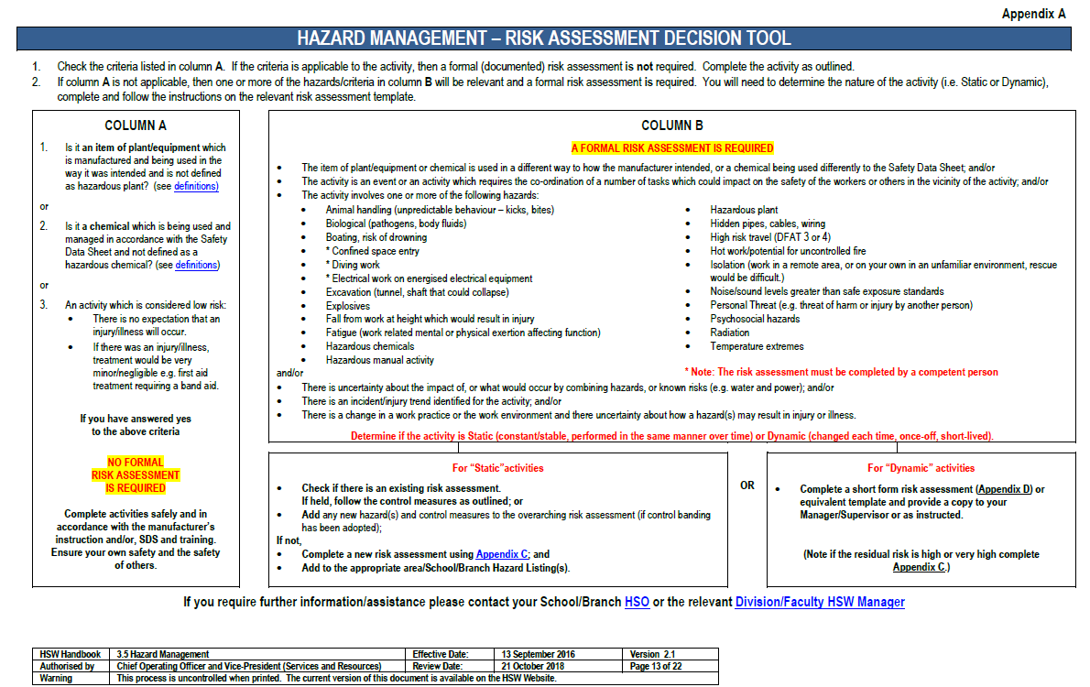

HAZARD MANAGEMENT | APPENDIX B (Page 2 of 2)

RISK ASSESSMENT TABLES

Three essential steps are taken:
- The probability or likelihood of an incident occurring is evaluated;
- The severity of the potential consequences is calculated or estimated;
- Based on these two factors, the risks are assigned priority for risk control through the use of a risk rating.

Risk assessment involves examining and evaluating the likelihood/severity/consequence in order to prioritise and implement adequate controls. The risk matrix has been adopted based on the principles of AS/NZS ISO 31000 (2009) Risk Management – Principles and Guidelines and Code of Practice “How to Manage Work Health and Safety Risks (2012).

Likelihood Table

CATEGORY | DESCRIPTION
Almost certain | There is an expectation that an event/incident will occur.
Likely | There is an expectation that an event/incident could occur but not certain to occur.
Slight | This expectation lies somewhere in the midpoint between “could” and “improbable”.
Unlikely | There is an expectation that an event/incident is doubtful or improbable to occur.
Rare | There is no expectation that the event/incident will occur.

Consequences Table

CATEGORY | DESCRIPTION
Severe | Injury resulting in death, permanent incapacity.
Major | Injury requiring extensive medical treatment, hospitalisation, or activities could result in a Notifiable occurrence.
Moderate | Injury requires formal medical treatment (hospital outpatient/doctors visit etc), activities could result in an Improvement Notice.
Minor | Injury requires first aid.
Negligible | Injury requires minor first aid (e.g. bandaid), or result in short term discomfort (e.g. bruise, headache, muscular aches etc), no medical treatment.

Risk matrix

Likelihood | Consequences
 | Negligible | Minor | Moderate | Major | Severe
Almost Certain | Medium | High | Very High | Very High | Very High
Likely | Medium | Medium | High | Very High | Very High
Slight | Low | Medium | High | High | Very High
Unlikely | Low | Low | Medium | Medium | High
Rare | Low | Low | Low | Medium | Medium

If the level of risk is assessed as high or very high
- Stop the activity; or
- Tag out the plant/equipment; or
- Secure any chemical; and
- Determine if the activity is to:
- continue; or
- cease
in consultation with your Manager/Supervisor.

Follow the process in 3.5.6.1 where the risk cannot be reduced to medium or low.

HSW Handbook | Events Safety Management (Information Sheet) | Effective Date: | 28 January 2016 | Version 1.0
Authorised by | Associate Director, HR Compliance and Improvement Services | Review Date: | 28 January 2019 | Page 7 of 15
Warning | This process is uncontrolled when printed. The current version of this document is available on the HSW Website.

