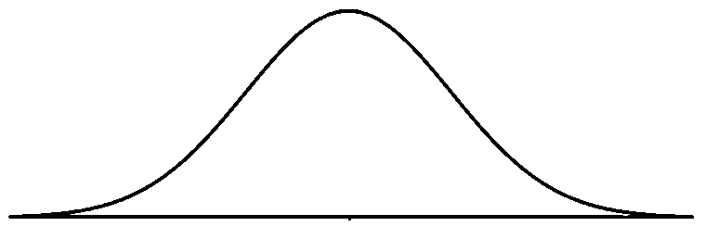
Normal distribution by png and boxes
Z
Z
Shaded area = 0.044
0
z = - 1.7
Shaded area = 0.95
0
z* = 1.96
-z*

