Adelaide Microscopy
File Naming Convention in 7 Steps

IMPORTANT: Check for established naming conventions within your research group

- What group of files will this naming convention cover?
You can reuse or create different conventions for different datasets.
Example: This convention will apply to all of my microscopy files, including the raw and processed image data from both microscope A and microscope B

- What attributes (metadata) are most important to these files to make each file distinct (pick 3-5)?
These attributes should be sufficient to visually scan file names and easily understand the contents of each file. A table of example attributes is provided on page 3 and may be relevant to your own samples.
Example: For my images, I want to know the mouse genetic strain, treatment group, specimen number and age.

- Can you abbreviate or encode these attributes?
The attributes you identified in step 2 may require lots of text to describe. In this case, you need to decide how to shorten this information. It is recommended you use discipline specific abbreviations where applicable, which will assist colleagues in the interpretation of your naming convention. Categorical attributes can be replaced with 2- or 3-letter codes; but be sure to document these.
Example: Genetic strain will use a 3-letter abbreviation (C57BL/6: “BL6”, BALB/c: “BaC”), age in weeks will use a 3-letter code of form “w##” (14 weeks old: “w14”; 16 weeks old: ”w16“).

- How will you order these attributes in the file name?
Think about how you want to sort and search through your files to determine what attribute should appear first in the file name. Default sorting arranges files in order of the file name, moving character by character (e.g. “Ab” before “Ac” before “Ba” etc.). If date is important, use the ISO 8601 standard for formatted dates (YYYY-MM-DD). This ensures dates are always sorted chronologically, where 11 Jan 2021 (2021-01-11) always appears before 10 Sept 2021 (2021-09-10)
Example: The genetic strain is the most important attribute, followed by the treatment, specimen number and mouse age.

1
2
3
4
5

- How will you separate each attribute in the file name?
To ensure file names are machine- and human-readable, use dashes “-“ and underscores “_” to separate attributes. Also, avoid spaces and special characters, e.g. ~!@#$%, as these will not be recognised by some software. Dates using ISO 8601 format YYYY-MM-DD are also easier to read than dates formatted YYYYMMDD. E.g. 11 Nov 2014 is 2014-11-11 vs. 20141111.
Example: A unique sample ID will use a code made up of strain, treatment and specimen number separated by hyphens (“-”). Underscores (“_”) will separate the remaining attributes.

- Is it important to track different versions of each file?
You can track different versions of an image file, e.g. raw or processed data, by appending version information within the file name.
Example: Where images are processed in the analysis workflow, the version type (e.g. raw, processed, binary) will be inserted within the file name (e.g. “_raw_”, “_proc_”, “_bin_”) and immediately prior to the image number.

- Putting it all together! Write down your file naming convention.
Make sure your file naming convention uses only alphanumeric characters, dashes and underscores. Note that some microscopes will append additional information to a file name, e.g. the image number and file format. Speak with your microscopist during instrument training for more details.
Example:
My file naming convention is strain-treatment-specimenNumber_age_version_imageNumber.fileFormat
Examples are BL6-OVX-03_w18_raw_0001.bmp and BaC-CTL-03_w22_raw_0001.bmp

Examples of Specimen Attributes
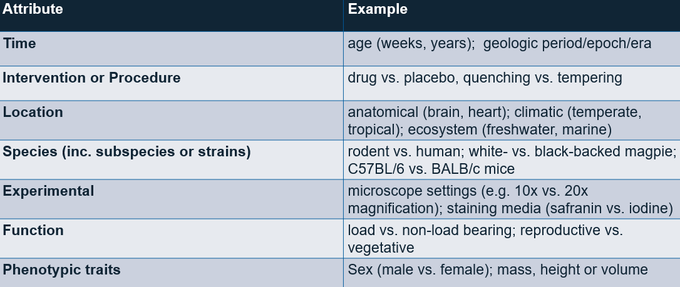

Attribution Statement: This worksheet is an adaptation of ‘File Naming Convention Worksheet’ by Kristin A. Briney and is used under a CC BY 4.0 license. Changes include revision of text to provide a microscopy specific example. The original document is available at link File Naming Convention Worksheet - CaltechAUTHORS

