New Starter Details
Name: | xx
Position: | xxx
School/Branch: |  | xxx | Commencement Date: | xxx
People Leader: |  | xxx | Induction Coordinator*: | xxx

This Induction Agenda has been personalised for you by your People Leader or Induction coordinator to support your transition into your new role. It includes an overview of what to expect for your induction over the coming 3 months, meetings that have been scheduled for you, and activities you may need to complete. Additional information and resources are available on the Induction website.
Pathway:

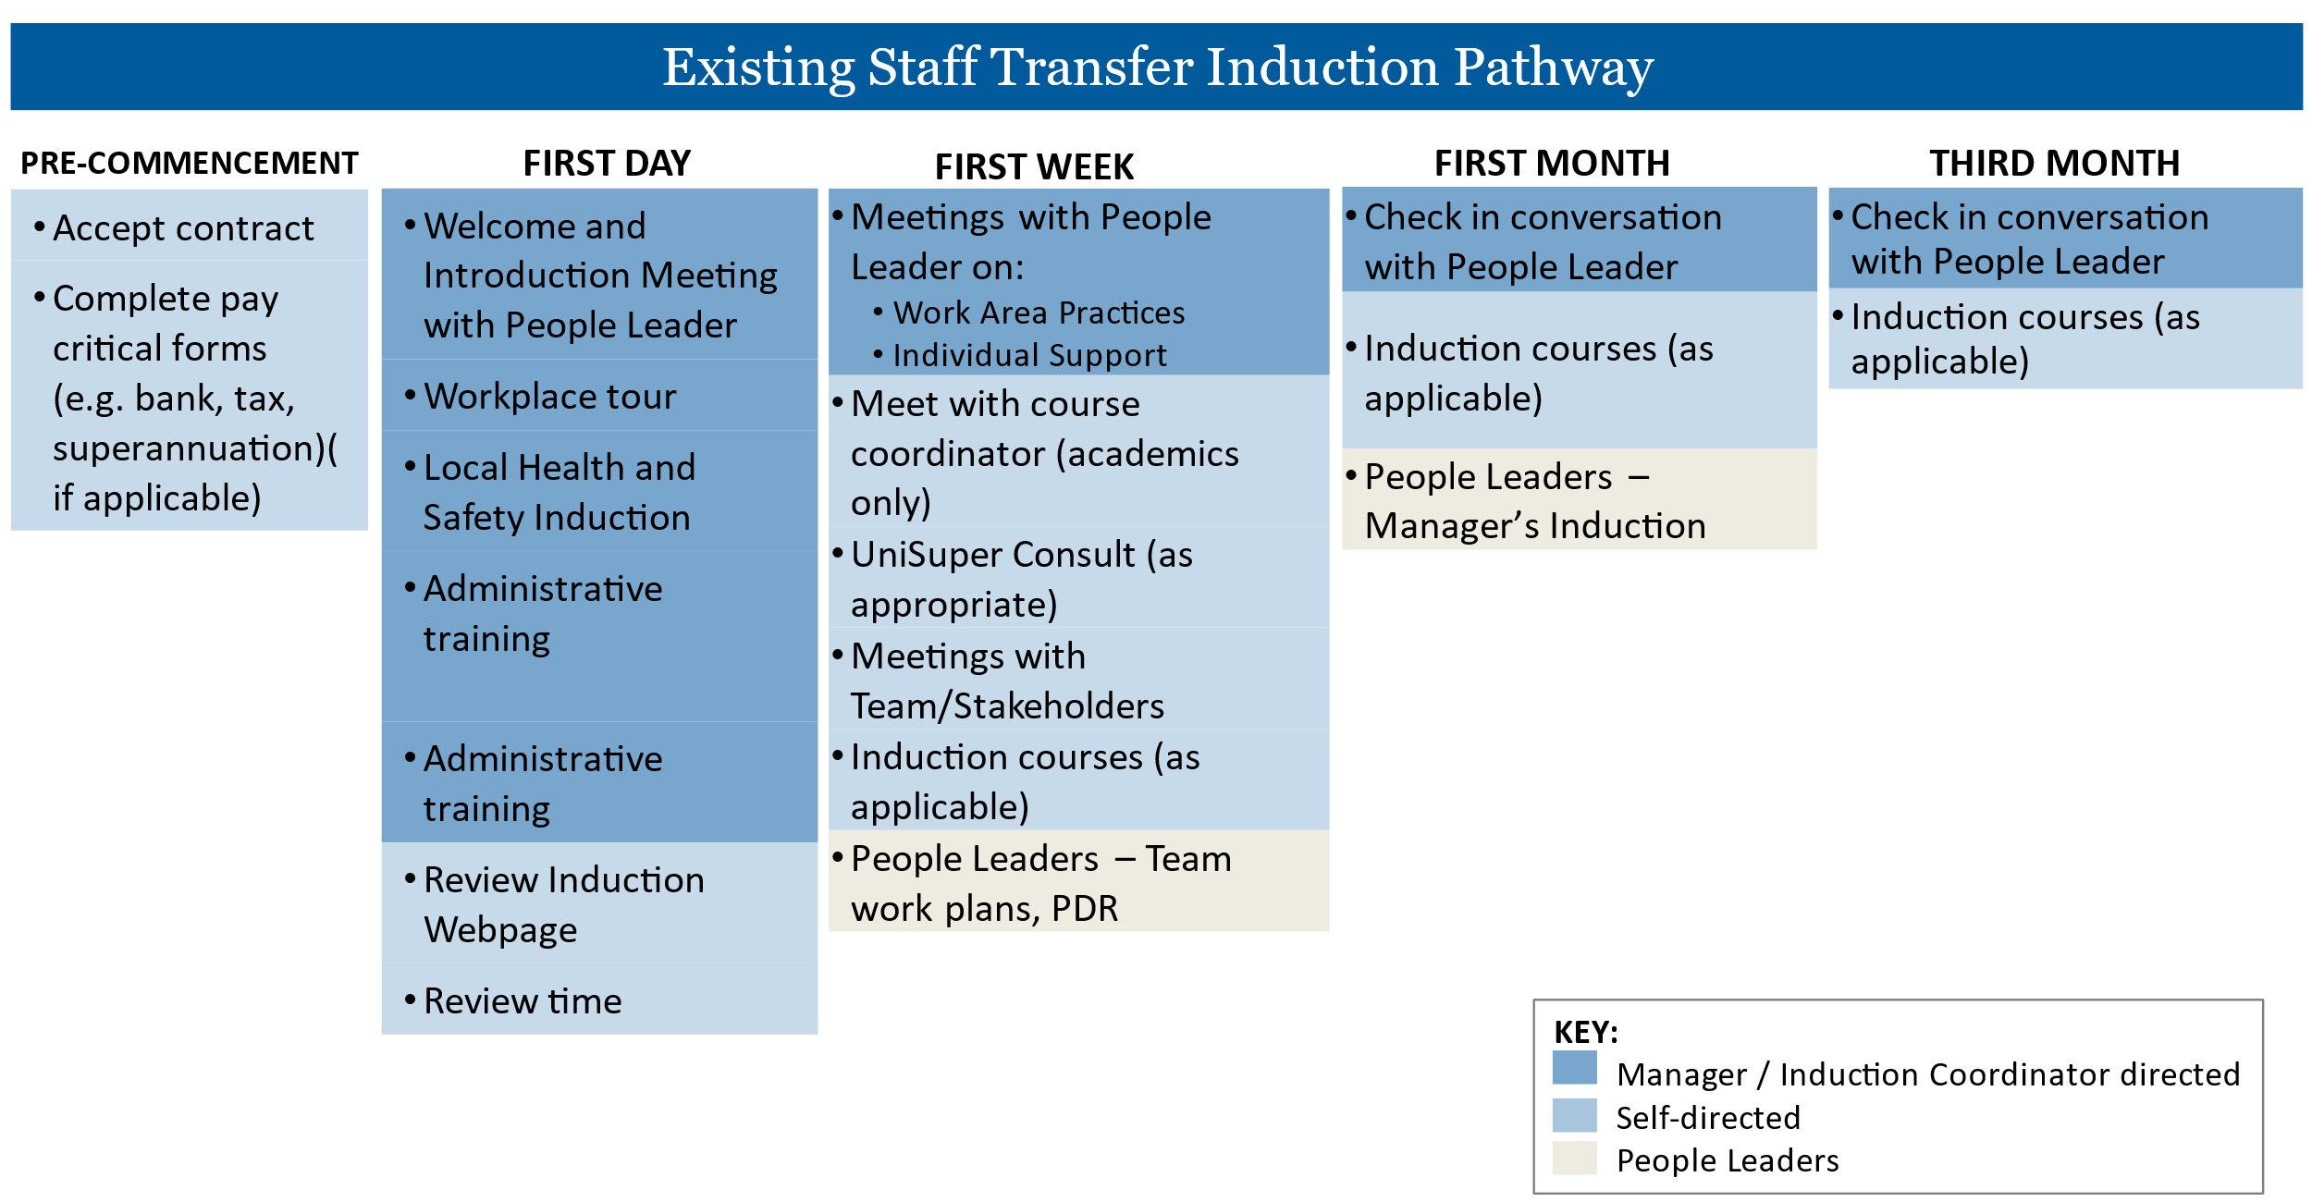

First Day
Time | Activity Description | Responsible
^These meetings may be combined depending on the people leader’s preferences
XXX | Welcome and Introduction Meeting^ - an opportunity to meet with your people leader and get oriented for your first day. | <People Leader >
XXX | Settle in time – set up computer, can start on ‘administrative training’ below if time. | New Starter
XXX | Workplace Tour - an opportunity to familiarise yourself with your local work area, including relevant facilities. | <Induction Coordinator>
 | Local Health and Safety Induction - more information about Health, Safety and Wellbeing | <People Leader >
XXX | Role Clarity Meeting^ - an opportunity to understand broad expectations of your role and initial priorities. | <People Leader >
 | Lunch – Free Time
XXX | Local Health and Safety Induction - more information about Health, Safety and Wellbeing | <People Leader >
XXX | Administrative Training  This list will help you set up upon arrival. Your induction coordinator or leader can assist with local practices like using Teams, shared drives, or office equipment.  ☐Set up email signature  ​​☐​MS Teams (if applicable)  ​​☐​Shared network drive - update or request S or R drive access  ​​☐​ Phone set up guide.  ☐ Request voicemail set up via this form.  ​​☐​Update your Staff Directory entry via this form.  ​​☐​Overview of office equipment (e.g. printer/photocopier). Information about Follow You Printing  ☐Assess the ergonomic setup of your workstation (resources are available to assist).  ☐Local intranet.  ☐Local Mail processes, if relevant (incoming, internal, external).  If you need any assistance with IT set up, you can contact IT support available via chat, phone (+61 8 8313 3000), service ticket, or self-service. | <Induction Coordinator>
 | Review time  ☐Review the Induction website.  ​​☐​HR website – Staff Services Online (SSO), Professional Development Review (PDR), Health, Safety and Wellbeing (HSW), Working At Adelaide  ​​☐​Marketing website (document templates and tools).  ☐IT Website. There is also some information about the basic University IT systems and how to access them on the Induction website here.  ☐Staff Services website with quick links to a range of staff services | New Starter

First Week and beyond
Date / Time | Activity Description | Responsible | or sign
XXX | Meeting/s with People Leader – opportunity to ask questions, troubleshoot issues, and clarify priorities. Common topics include university context, policies and procedures, and work area practices. | <People Leader>
 | Relevant Learning  - Review the induction courses to see if your change in role mans any additional induction courses may be relevant to you  - Epigeum Research Integrity course (if applicable) | New Starter
UniSuper Consult (as appropriate)
UniSuper is the University’s nominated default fund and a complimentary UniSuper consultation is available to you. You can schedule a meeting online.
You can also check out this 6-minute video to understand UniSuper a little more.
 | Team/Stakeholder meetings as required  - Attend meetings with team members and/or stakeholders as scheduled. | New Starter
 | <Stakeholder meeting>
 | Are you a People Leader?  - Meet with your team to discuss work plans and existing team priorities.  - Meet with Individual team members to discuss the objectives in their Professional Development Reviews (PDRs).  - There are a number of resources to support you in your role as a people manager at the University located on the Manager’s Induction webpage. For further information, please contact learninganddevelopment@adelaide.edu.au | New Starter

Congratulations!
At the end of 3 months, you have come a long way in getting to know your new role, team, and the organisation. While induction initiatives are typically targeted in the first 3-months, learning is at the heart of everything we do and we anticipate your learning will continue. Don’t hesitate to come back to the induction website, courses, and, most importantly, the support networks you’ve built through your induction process as you continue in your role.

