STUDENTS AS PARTNERS

PROJECT SCOPE FORM



This f o rm is intended to clarify how you wish to engage Student as Partners (SaP) within your project.

After you've submitted this form, the Student as Partners (SaP) team will evaluate it. If the project is deemed feasible, the SaP team will provide support in terms of promotion, recruitment, shortlisting, and facilitating insurance agreements. The SaP team will collaborate with you and your student partners to establish the project and remain available for necessary support throughout its duration.

# ABOUT

PROJECT

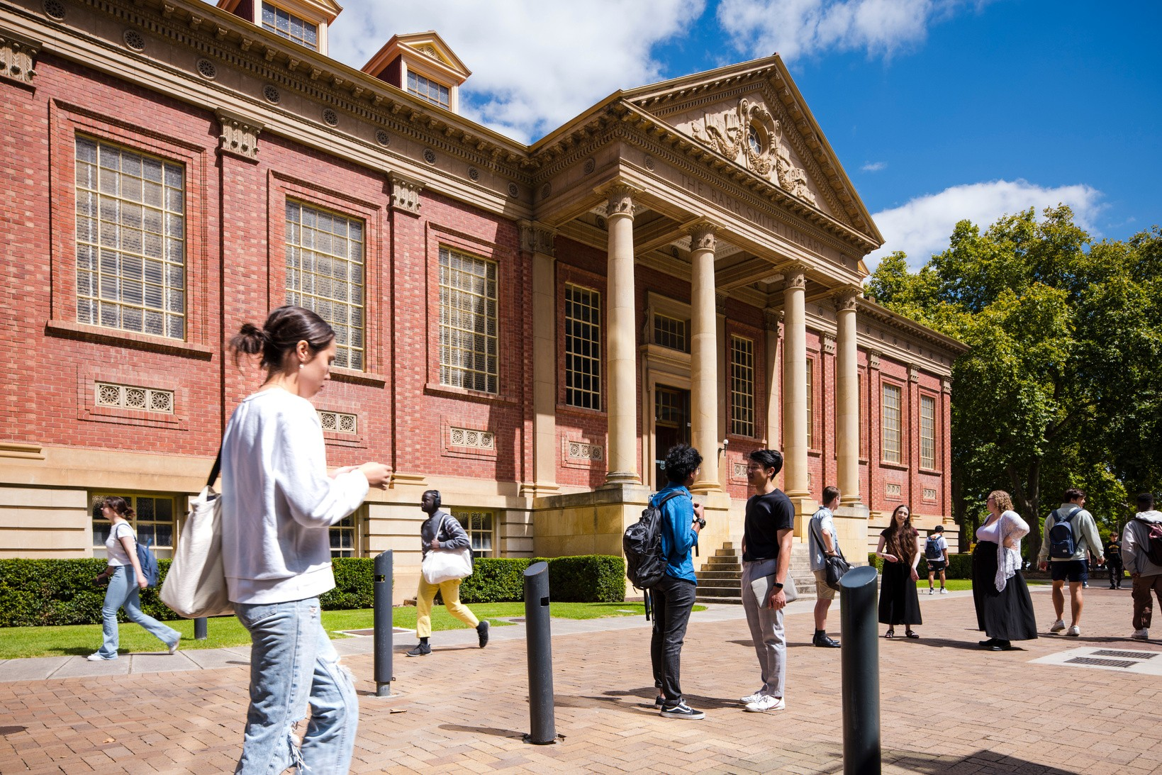

Title of project:

Purpose/aims:

Summary:

# PROJECT TEAM



Lead(s):

Supporting staff (if applicable):

Area/department:

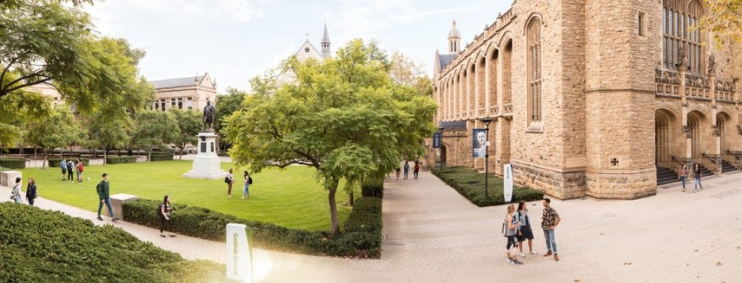

## THE WHAT

What key skills, experiences and outputs are you looking for from your student partner(s)?

What do you expect the total hours to be / how long will this project run for?

What are the working hours? Is this flexible? How will you accommodate student commitments?

## THE HOW

How many Students as Partners do you believe will be required for your project?

How will you be employing the partners? How will you be recognising their efforts?

How will the partners engage with you on your project?

How will you measure the success of your project?

## THE HOW

How will you be inducting and training the partners for your project?

*Feel free to refer to the Students as Partners Framework.*

## METHOD

How will you be running your project?

Thank you for your submission. Please forward your

completed scope form to Student as Partners Team:

[anthea**.**daloia@adelaide**.**edu**.**au](mailto:anthea.daloia@adelaide.edu.au).

We will be in touch shortly.