Sync your ORCiD to figshare

Introduction
ORCiD stands for Open Researcher and Contributor ID. It is a persistent digital identifier that distinguishes you from every other researcher, throughout your career.
The University requires current and new Academic staff and Higher Degree by Research students to obtain an ID for linking to various University research systems, and to better capture an overview of your growing research output.
Follow this guide to sync your existing ORCiD with University of Adelaide figshare. If they are linked, metadata datasets and some other item types published on figshare will be published to your ORCiD profile.

Procedure
Note: If you haven’t signed up for ORCiD, read the Create your ORCiD instructions at the end of this document
- Navigate to your figshare profile by clicking on the small circle with your initials or photo, and selecting Profile.
- Click on CONNECT next to the ORCiD field and Add account.
- Enter your ORCiD or email address and ORCiD password and click Authorize to sync your ORCiD and figshare profile.
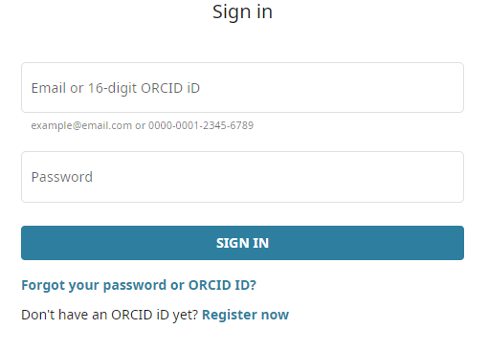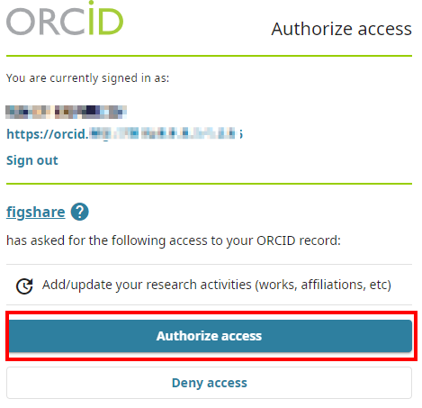

- You’ll be presented with three options. These are all set to “Off” by default.
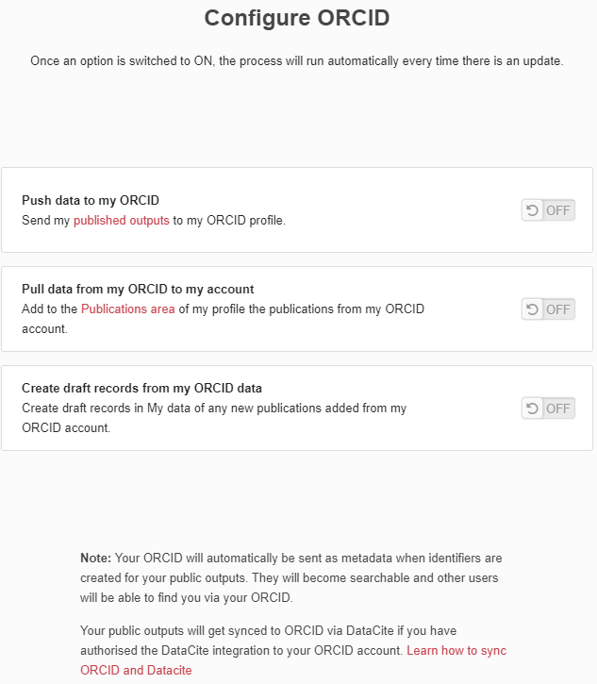

- Push data to my ORCiD [RECOMMENDED]
This option creates a record in your ORCID account of any items that you publish on Figshare. It’s good to note that this will create a record using the base DOI only, versioned DOIs are omitted. The base DOI will always point to the latest version of your item.
This feature will only kick in for items created after the initial integration has been performed. Any existing items in your figshare account will not be pushed using this method. If you would like historic figshare items to show in your ORCID account, this will need to be done manually
- Pull data from my ORCID to my figshare account [OPTIONAL]
This option will import everything in your ORCID works section to the Publications area of your figshare profile. Unlike the previous setting, this will import everything BEFORE the integration was performed as well as anything created ongoing.
- Create draft records from my ORCID data [NOT RECOMMENDED]
AURORA is the preferred University metadata repository for publications and research outputs and they should continue to be deposited there. AURORA is integrated with other University systems and enables you to reliably and effectively track your outputs.
If you choose to turn on this option, after the integration has occurred any new records created within the works section of your ORCID account will automatically create a new draft metadata record within your My Data area in figshare, based on the information within that record and with the DOI of the original object.
When a new draft item has been created, you’ll get two kinds of notifications: an email to your account email address and a notification within figshare. You can then choose to add a file for the record, such as an open access version of a publication, and any additional metadata or you can delete the draft record if it’s not needed.
PLEASE NOTE: If you do choose to import records from your ORCID account into figshare, you will still need to ensure you deposit copies of those outputs into AURORA as well.

Create your ORCiD
Create your ORCiD via the University of Adelaide ORCiD page http://orcid.adelaide.edu.au, not the figshare My Profile page. Creating it via the University of Adelaide ORCiD page will enable you to register your ORCiD with the University to provide updating of information between ORCiD and the University of Adelaide systems.
For more information on creating ORCiDs, see the ORCiD support materials page.

- Open the University of Adelaide ORCiD page and click I NEED AN ORCiD ID.
- Complete the required fields and click Register.
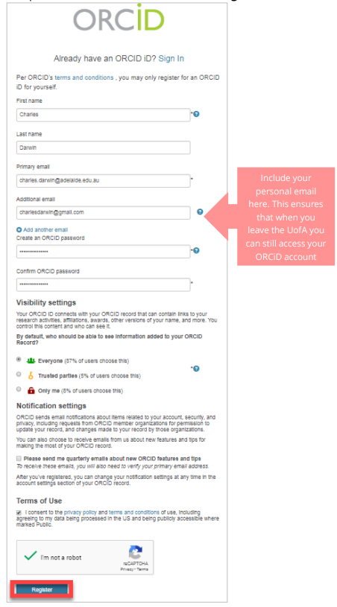
- Select Authorize to link your ORCiD with the University of Adelaide and a conformation will appear with your new ORCiD details.

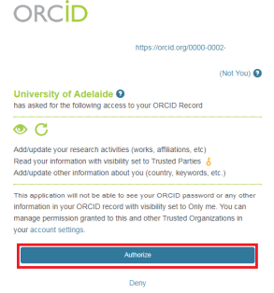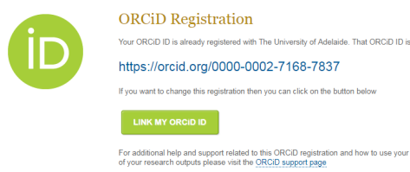

You can now sync your ORCiD with your figshare profile.

Contact Us
For further support or questions, please contact ITDS on +61 8 8313 3000 or https://uniadelaide.service-now.com/myit

University of Adelaide Research Data and Primary Materials Policy https://www.adelaide.edu.au/policies/4043/

